**Learn Enough Git to Be Dangerous Michael Hartl**

An Introduction to Version Control with Git

[**Chapter 1 Getting started**](https://www.learnenough.com/git-tutorial?single_page=1#cha-getting_started)

A version control system, or *VCS*, provides an automatic way to track changes in software projects, giving creators the power to view previous versions of files and directories, develop speculative features without disrupting the main development, securely back up the project and its history, and collaborate easily and conveniently with others. In addition, using version control also makes deploying production websites and web applications much easier.

Version control has evolved considerably over the years. The family line leading to Git includes programs called RCS, CVS, and Subversion, and there are many current alternatives as well, including Perforce, Bazaar, and Mercurial. I mention these examples not because you need to know what they are, but only to show what a bewildering variety there is. What’s worse, when you choose a version control system, you really *commit* to it,[1](https://www.learnenough.com/git-tutorial?single_page=1#cha-1_footnote-1) and it is often difficult to switch from one to another. Happily, in the last few years an undisputed winner has emerged in the open-source VCS wars: Git.

Git has a combination of power, speed, and community adoption that leave it few rivals, but it can be tricky to learn, and other Git tutorials have a tendency to introduce lots of heavy theory, which can be interesting to learn but in practice is really only understood by a tiny handful of Git users (as illustrated in “[Git](https://m.xkcd.com/1597/)” via the webcomic [xkcd](https://xkcd.com/)).

[**1.1 Installation and setup**](https://www.learnenough.com/git-tutorial?single_page=1#sec-installation_and_setup)

After installing Git but before starting a project, we need to perform a couple of one-time setup steps, as shown in [Listing 1.1](https://www.learnenough.com/git-tutorial?single_page=1#code-global_config). These are *global* setups, meaning you only have to do them once per computer. (Don’t worry about the meaning or structure of these commands at this stage.)

Listing 1.1: One-time global configuration settings.

$ git config --global user.name "Your Name"

$ git config --global user.email your.email@example.com

These configuration settings allow Git to identify your changes by name and email address, which is especially helpful when collaborating with others ([Chapter 4](https://www.learnenough.com/git-tutorial?single_page=1#cha-collaborating)). Note that the name and email you use in [Listing 1.1](https://www.learnenough.com/git-tutorial?single_page=1#code-global_config) will be viewable in any projects you make public, so don’t expose any information you’d rather keep private.

Git stores global configuration settings in a hidden text file located in your home directory. By inspecting the file ~/.gitconfig with a tool of your choice (cat, less, a text editor, etc.), confirm that the configuration set up by [Listing 1.1](https://www.learnenough.com/git-tutorial?single_page=1#code-global_config) corresponds to simple text entries in this file.

[**1.2 Initializing the repo**](https://www.learnenough.com/git-tutorial?single_page=1#sec-initializing_the_repo)

We’ll begin by making a directory with the generic name website inside a repositories directory called repos:

[~]$ mkdir -p repos/website

Here the -p option, arranges for mkdir to create intermediate directories as required (in this case, repos). After making the directory, we can cd into it as follows:

[~]$ cd repos/website/

[website]$

Even though the website directory is empty, we can already convert it to a *repository*, which you can think of as a sort of enhanced directory with the additional ability to track changes to every file and subdirectory. The way to create a new repository with Git is with the init command (short for “initialize”), which creates a special hidden directory called .git where Git stores the information it needs to track our project’s changes. (It’s the presence of a properly configured .git directory that distinguishes a Git repository from a regular directory.)

All Git commands consist of the command-line program git followed by the name of the command, so the full command to initialize a repository is git init, as shown in [Listing 1.2](https://www.learnenough.com/git-tutorial?single_page=1#code-git_init).

Listing 1.2: Initializing a Git repository.

[website]$ git init

Initialized empty Git repository in /Users/mhartl/repos/website/.git/

[website (master)]$

[**1.3 Our first commit**](https://www.learnenough.com/git-tutorial?single_page=1#sec-our_first_commit)

Git won’t let us complete the initialization of the repository while it’s empty, so we need to make a change to the current directory. We’ll simply use touch to create an empty file.

[website (master)]$ touch index.html

Having created this first file, we can use the git status command to see the result:

We see here that the index.html file is “untracked”, which means Git doesn’t yet know about it. We can *add* it using the git add command:

[website (master)]$ git add -A

Here the -A option tells Git to add *all* untracked files, even though in this case there’s only one. In my experience, 99% of the time you add files you’ll want to add them all, so this is a good habit to cultivate, and learning how to add individual files is left as an exercise ([Section 1.3.1](https://www.learnenough.com/git-tutorial?single_page=1#sec-exercises_our_first_commit)). (By the way, the equivalent command git add ., where the dot refers to the [current directory](https://www.learnenough.com/r/learn_enough_command_line/directories/navigating_directories#sec-navigating_directories), is also common.)

As implied by the word “unstage”, the status of the file has been promoted from *untracked* to *staged*, which means the file is ready to be added to the repository. *Untracked/unstaged* and *staged* are two of the four states commonly used by Git, as shown in [Figure 1.1](https://www.learnenough.com/git-tutorial?single_page=1#fig-git_status_sequence). ([Technically](https://m.xkcd.com/1475/), untracked and unstaged are different states, but the distinction is rarely important because git add tracks and stages files at the same time.)

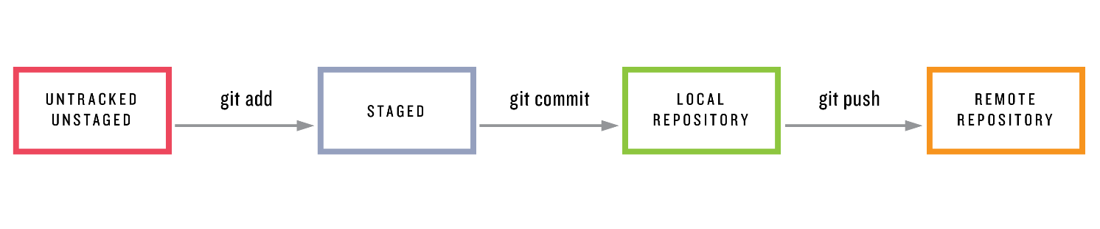

Figure 1.1: The main Git status sequence for a changing file.

After putting changes in the staging area we can make them part of the local repository by *committing* them using git commit. (We’ll cover the final step from [Figure 1.1](https://www.learnenough.com/git-tutorial?single_page=1#fig-git_status_sequence), git push, in [Section 2.3](https://www.learnenough.com/git-tutorial?single_page=1#sec-adding_a_readme).)

At this point, we can use git log to see a record of our commit:

The commit is identified by a *hash*, which is a unique string of letters and numbers that Git uses to label the commit and which lets Git retrieve the commit’s changes. In my case, the hash appears as

879392a6bd8dd505f21876869de99d73f40299cc

but since each hash is unique your result will differ. The hash is often referred to as a “SHA” (pronounced *shah*) because of the acronym for the [Secure Hash Algorithm](https://en.wikipedia.org/wiki/SHA-1) used to generate it.

[**1.4 Viewing the diff**](https://www.learnenough.com/git-tutorial?single_page=1#sec-viewing_the_diff)

It’s often useful to be able to view the changes represented by a potential commit before making it. To see how this works, let’s add a little bit of content to index.html by [redirecting the output](https://www.learnenough.com/r/learn_enough_command_line/manipulating_files/redirecting_and_appending#sec-redirecting_and_appending) of echo to make a “hello, world” page:

[website (master)]$ echo "hello, world" > index.html

The Unix diff utility lets us compare two files foo and bar by typing

$ diff foo bar

Git has a similar function, git diff, which by default just shows the difference between the last commit and unstaged changes in the current project:

We can commit this change by passing the -a option (for “all”) to git commit, which arranges to commit all the changes in currently existing files ([Listing 1.3](https://www.learnenough.com/git-tutorial?single_page=1#code-git_commit_a_m)).

Note that the -a option includes changes only to files already added to the repository, so when there are new files it’s important to run git add -A as in [Section 1.3](https://www.learnenough.com/git-tutorial?single_page=1#sec-our_first_commit) to make sure they’re added properly. It’s easy to get in the habit of running git commit -a and forget to add new files explicitly; learning how to deal with this situation is left as an exercise ([Section 1.4.1](https://www.learnenough.com/git-tutorial?single_page=1#sec-exercises_viewing_the_diff)).

Having added and committed the changes, there’s now no diff:

[website (master)]$ git diff

[website (master)]$

(In fact, simply adding the changes is sufficient; running git add -A would also lead to there being no diff. To see the difference between staged changes and the previous version of the repo, use git diff --staged.)

We can confirm that the change went through by running git log:

[website (master)]$ git log

commit 03aff34ec4f9690228e057a4252bcca169a868b4

Author: Michael Hartl <michael@michaelhartl.com>

Date: Thu Dec 17 20:03:33 2015 -0800

Add content to index.html

commit 879392a6bd8dd505f21876869de99d73f40299cc

Author: Michael Hartl <michael@michaelhartl.com>

Date: Thu Dec 17 20:00:34 2015 -0800

Initialize repository

[**1.4.1 Exercises**](https://www.learnenough.com/git-tutorial?single_page=1#sec-exercises_viewing_the_diff)

1. Use touch to create an empty file called baz. What happens if you run git commit -am "Add baz"?
2. Add baz to the staging area using git add -A, then commit with the message "Add bazz".
3. Realizing there’s a typo in your commit message, change bazz to baz using git commit --amend.
4. Run git log to get the SHA of the last commit, then view the diff using git show <SHA> to verify that the message was amended properly.

[**1.5 Adding an HTML tag**](https://www.learnenough.com/git-tutorial?single_page=1#sec-adding_a_tag)

We’ve now seen all of the major elements involved in the simplest Git workflow, so in this section and the next we’ll review what we’ve done and see how everything fits together. We’ll err on the side of making more frequent commits, representing relatively modest changes, but this isn’t necessarily how you should work in real life ([Box 1.5](https://www.learnenough.com/git-tutorial?single_page=1#aside-commitment_issues)). Still, it’s an excellent foundation, and it will give you a solid base on which to build your own workflow and development practices.

Box 1.5. Commitment issues

One common issue when learning Git involves figuring out when to make a commit. Unfortunately, there’s no simple answer, and real-life usage varies considerably (as illustrated in the [xkcd](https://xkcd.com/) comic strip “[Git Commit](https://m.xkcd.com/1296/)”). My best advice is to make a commit whenever you’ve reached a natural stopping point, or when you’ve made enough changes that you’re starting to worry about losing them. In practice, this can lead to inconsistent results, and it’s common to work for a while and make a large commit and then make a minor unrelated change with a small commit. This mismatch between commit sizes can seem a little weird, but it’s a difficult situation to avoid.

Many teams (including most open-source projects) have their own conventions for commits, including the practice of *squashing* commits to combine them all into one commit for convenience. (Per [Box 1.2](https://www.learnenough.com/git-tutorial?single_page=1#aside-technical_sophistication), this is exactly the kind of thing you can learn about by [Googling for it](https://www.google.com/search?q=git+squash+commits).) In these circumstances, I recommend following the conventions adopted by the project in question.

More than anything, don’t worry about it too much. “[Git Commit](https://m.xkcd.com/1296/)” is a only a slight exaggeration, and in any case deciding when to commit is the kind of thing that you’ll invariably get better at with time and experience.

As in previous sections, we’ll be working on the main index.html file. Let’s start by opening this file in both a text editor and in a web browser. My preferred method for doing this is at the command line using the atom and open commands (though the latter works only on macOS):

[website (master)]$ atom index.html # or open index.html

If you’re not on a Mac (or even if you are), you can open the directory using a graphical file browser and double-clicking the file to open it in the default browser ([Figure 1.2](https://www.learnenough.com/git-tutorial?single_page=1#fig-index_filesystem_browser)). However you open the file, the results should appear approximately as shown in [Figure 1.3](https://www.learnenough.com/git-tutorial?single_page=1#fig-hello_world_atom) and [Figure 1.4](https://www.learnenough.com/git-tutorial?single_page=1#fig-hello_world_browser).

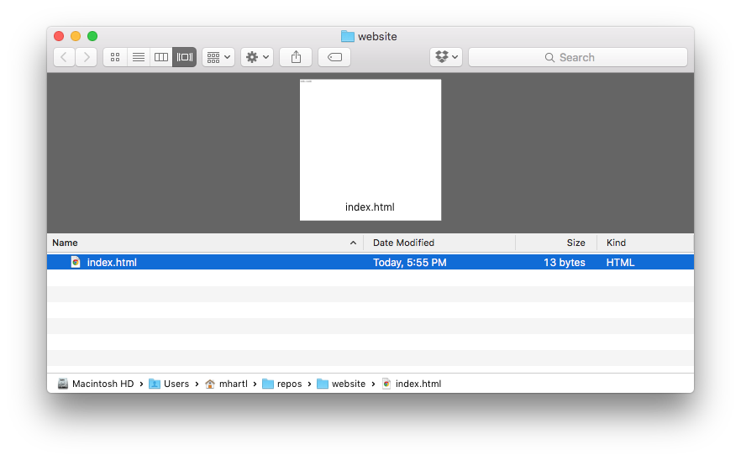

Figure 1.2: Viewing index.html in a filesystem browser.

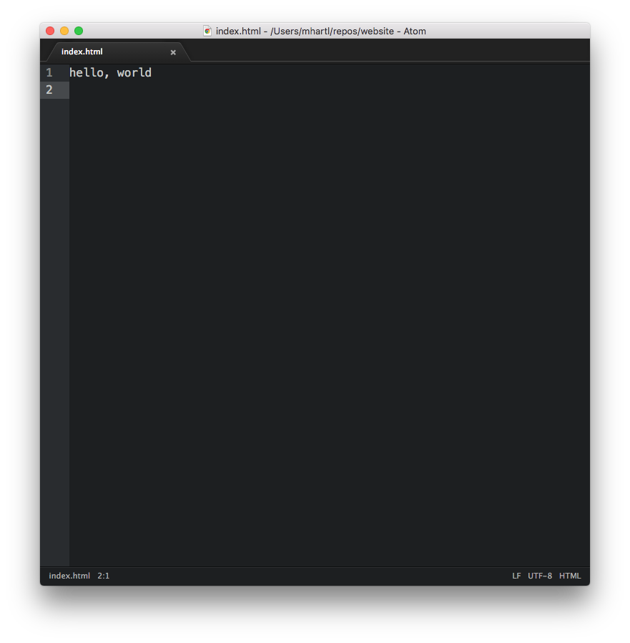

Figure 1.3: The initial HTML file opened in Atom.

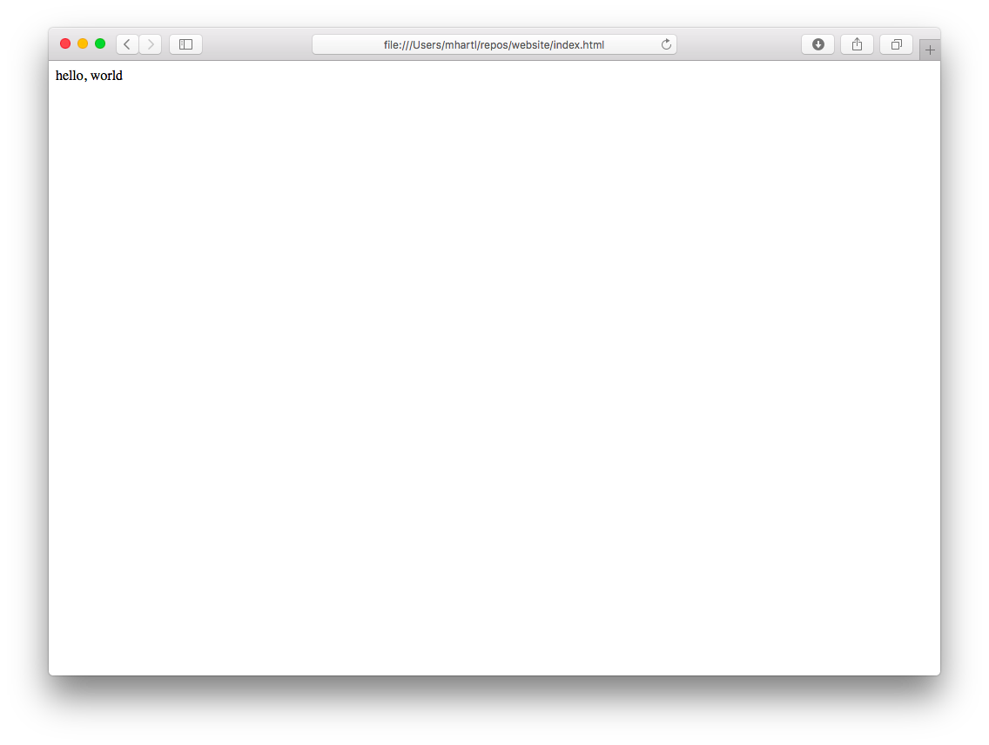

Figure 1.4: The initial HTML file viewed in a web browser.

At this point, we’re ready to make a change, which is to promote “hello, world” from ordinary text to a top-level (Level 1) heading. In HTML, the language of the World Wide Web, the way to do this is with a *tag*—in this case, the Level 1 header tag h1. Most browsers set h1 tags in a large font, so the text hello, world should look bigger when we’re done. To make the change, replace the current contents of index.html with the contents shown in [Listing 1.4](https://www.learnenough.com/git-tutorial?single_page=1#code-hello_world_h1). (In this and all other examples of editing text, you’ll learn more if you type in everything by hand instead of copying and pasting.)

Listing 1.4: A top-level heading.

<h1>hello, world</h1>

[Listing 1.4](https://www.learnenough.com/git-tutorial?single_page=1#code-hello_world_h1) shows the basic structure used by most HTML tags. First, there’s an *opening tag* that looks like <h1>, where the angle brackets < and > surround the tag name (in this case, h1). After the content, there’s a *closing tag* that’s the same as the opening tag, except with an extra slash after the opening angle bracket: </h1>. (Note that, as with addresses on the World Wide Web, this is a *slash*, not a *backslash* (a common confusion humourously referenced in the [xkcd](https://xkcd.com/) comic strip “[Trade expert](https://m.xkcd.com/727/)”).)

Upon refreshing the web browser, the index page should appear something like [Figure 1.5](https://www.learnenough.com/git-tutorial?single_page=1#fig-hello_world_h1). As promised, the font size of the text for the top-level heading is bigger (and bolder, too).

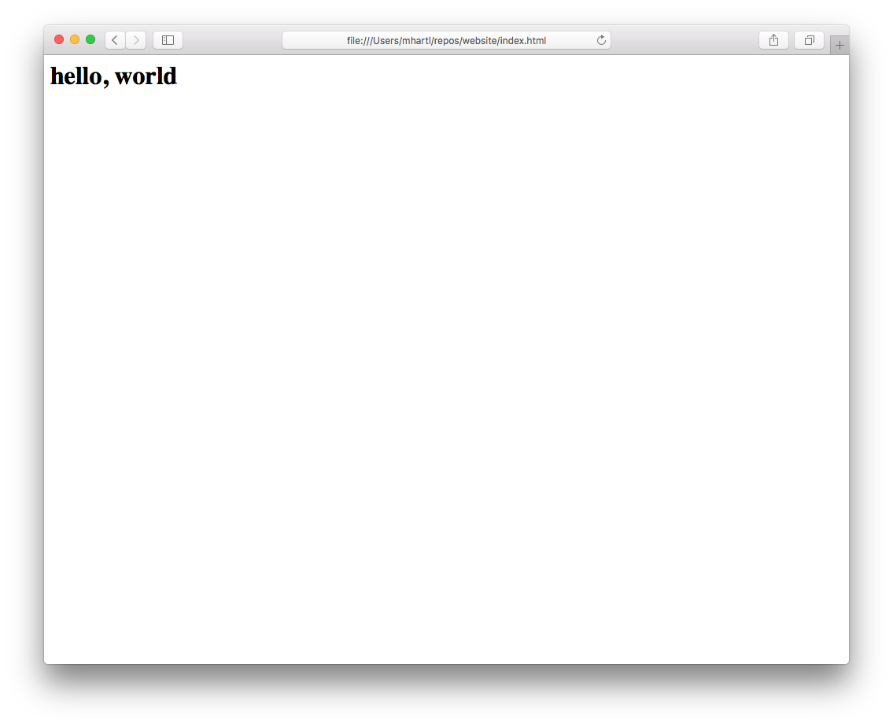

Figure 1.5: The result of adding an h1 tag.

As before, we’ll run git status and git diff to learn more about what we’re going to commit to Git, though with experience you’ll come to run these commands only when necessary. The status simply indicates that index.html has been modified:

[website (master)]$ git status

On branch master

Changes not staged for commit:

(use "git add <file>..." to update what will be committed)

(use "git checkout -- <file>..." to discard changes in working directory)

modified: index.html

no changes added to commit (use "git add" and/or "git commit -a")

Meanwhile, the diff shows that one line has been deleted (indicated with -) and another added (indicated with +):

[website (master)]$ git diff

diff --git a/index.html b/index.html

index 4b5fa63..45d754a 100644

--- a/index.html

+++ b/index.html

@@ -1 +1 @@

-hello, world

+<h1>hello, world</h1>

As with the Unix diff utility, modified sections of code or markup are shown as close to each other as possible so that it’s clear at a glance what changed.[6](https://www.learnenough.com/git-tutorial?single_page=1#cha-1_footnote-6)

At this point, we’re ready to commit our changes. In [Listing 1.3](https://www.learnenough.com/git-tutorial?single_page=1#code-git_commit_a_m) we used both the -a and -m options to commit **a**ll pending changes while adding a commit **m**essage, but in fact the two can be combined as -am ([Listing 1.5](https://www.learnenough.com/git-tutorial?single_page=1#code-git_commit_am)).

Listing 1.5: Committing with -am.

[website (master)]$ git commit -am "Add an h1 tag"

Using the -am combination as in [Listing 1.5](https://www.learnenough.com/git-tutorial?single_page=1#code-git_commit_am) is common in idiomatic Git usage.

[**1.5.1 Exercises**](https://www.learnenough.com/git-tutorial?single_page=1#sec-exercises_adding_a_tag)

1. The git log command shows only the commit messages, which makes for a compact display but isn’t particularly detailed. Verify by running git log -p that the -p option shows the full diffs represented by each commit.
2. Under the h1 tag in [Listing 1.4](https://www.learnenough.com/git-tutorial?single_page=1#code-hello_world_h1), use the p tag to add a *paragraph* consisting of the line “Call me Ishmael.” The result should appear as in [Figure 1.6](https://www.learnenough.com/git-tutorial?single_page=1#fig-ishmael_paragraph). (Don’t worry if you get stuck; we’ll incorporate the answer to this exercise in [Section 1.6](https://www.learnenough.com/git-tutorial?single_page=1#sec-adding_html_structure) ([Listing 1.6](https://www.learnenough.com/git-tutorial?single_page=1#code-html_structure)).)

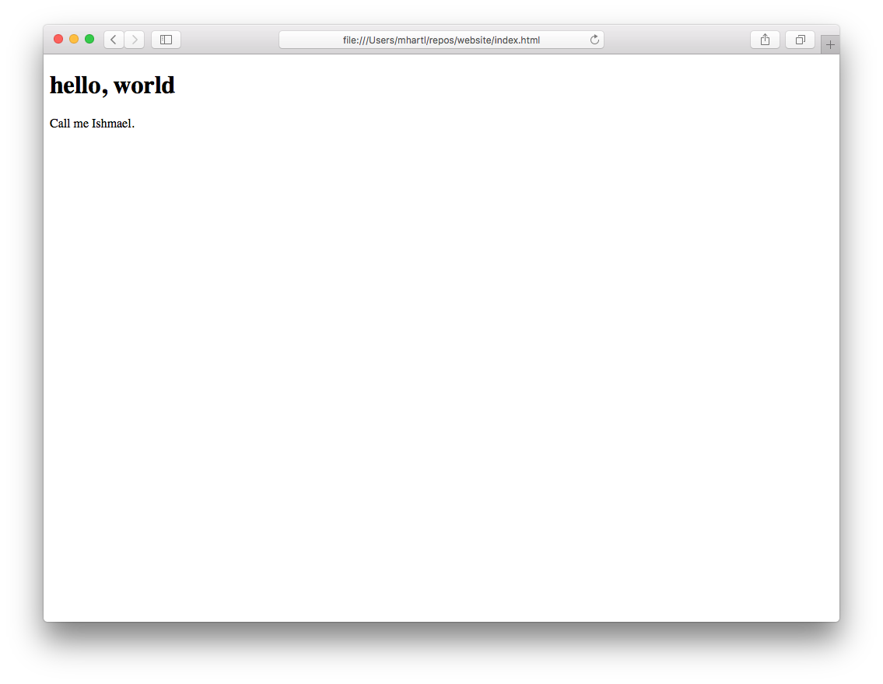

Figure 1.6: The result of adding a short paragraph.

[**1.6 Adding HTML structure**](https://www.learnenough.com/git-tutorial?single_page=1#sec-adding_html_structure)

Although the web browser correctly rendered the h1 tag in [Figure 1.5](https://www.learnenough.com/git-tutorial?single_page=1#fig-hello_world_h1), properly formatted HTML pages have more structure than just bare h1 or p tags. In particular, each page should have an html tag consisting of a *head* and a *body* (identified with head and body tags, respectively), as well as a “doctype” identifying the document type, which in this case is a particular version of HTML called HTML5. (Don’t worry about these details now; we’ll cover them in more depth in [*Learn Enough HTML to Be Dangerous*](https://www.learnenough.com/html).)

Applying these general considerations to index.html leads to the full HTML structure shown in [Listing 1.6](https://www.learnenough.com/git-tutorial?single_page=1#code-html_structure). This includes the h1 tag from [Listing 1.4](https://www.learnenough.com/git-tutorial?single_page=1#code-hello_world_h1) and the paragraph tag from [Figure 1.6](https://www.learnenough.com/git-tutorial?single_page=1#fig-ishmael_paragraph). (The title tag, included inside the head tag, is empty, but in general every page should have a title, and adding one for index.html is left as an exercise ([Section 1.6.1](https://www.learnenough.com/git-tutorial?single_page=1#sec-exercises_adding_html_structure)).)

Listing 1.6: The HTML page with added structure.

1 <!DOCTYPE html>

2 <html>

3 <head>

4 <title></title>

5 </head>

6 <body>

7 <h1>hello, world</h1>

8 <p>Call me Ishmael.</p>

9 </body>

10 </html>

Because this is a lot more content than our previous iteration ([Listing 1.4](https://www.learnenough.com/git-tutorial?single_page=1#code-hello_world_h1)), it’s a good idea to go through it line by line:

1. The document type declaration
2. Opening html tag
3. Opening head tag
4. Opening and closing title tags
5. Closing head tag
6. Opening body tag
7. Top-level heading
8. Paragraph from the exercises ([Section 1.5.1](https://www.learnenough.com/git-tutorial?single_page=1#sec-exercises_adding_a_tag))
9. Closing body tag
10. Closing html tag

As usual, we can see the changes represented by our addition using git diff ([Listing 1.7](https://www.learnenough.com/git-tutorial?single_page=1#code-diff_html_structure)).

Listing 1.7: The diff for adding HTML structure.

[website (master)]$ git diff

diff --git a/index.html b/index.html

index 4b5fa63..afcd202 100644

--- a/index.html

+++ b/index.html

@@ -1 +1,10 @@

-<h1>hello, world</h1>

+<!DOCTYPE html>

+<html>

+ <head>

+ <title></title>

+ </head>

+ <body>

+ <h1>hello, world</h1>

+ <p>Call me Ishmael.</p>

+ </body>

+</html>

Despite the extensive diffs in [Listing 1.7](https://www.learnenough.com/git-tutorial?single_page=1#code-diff_html_structure), there are hardly any user-visible differences ([Figure 1.7](https://www.learnenough.com/git-tutorial?single_page=1#fig-html_structure)); the only change from [Figure 1.6](https://www.learnenough.com/git-tutorial?single_page=1#fig-ishmael_paragraph) is a small amount of space above the top-level heading. The structure is much better, though, and brings our page nearly into compliance with the HTML5 standard. (It’s not quite valid, because a nonblank page title is required by the standard; fixing this issue is left as an exercise ([Section 1.6.1](https://www.learnenough.com/git-tutorial?single_page=1#sec-exercises_adding_html_structure)).)

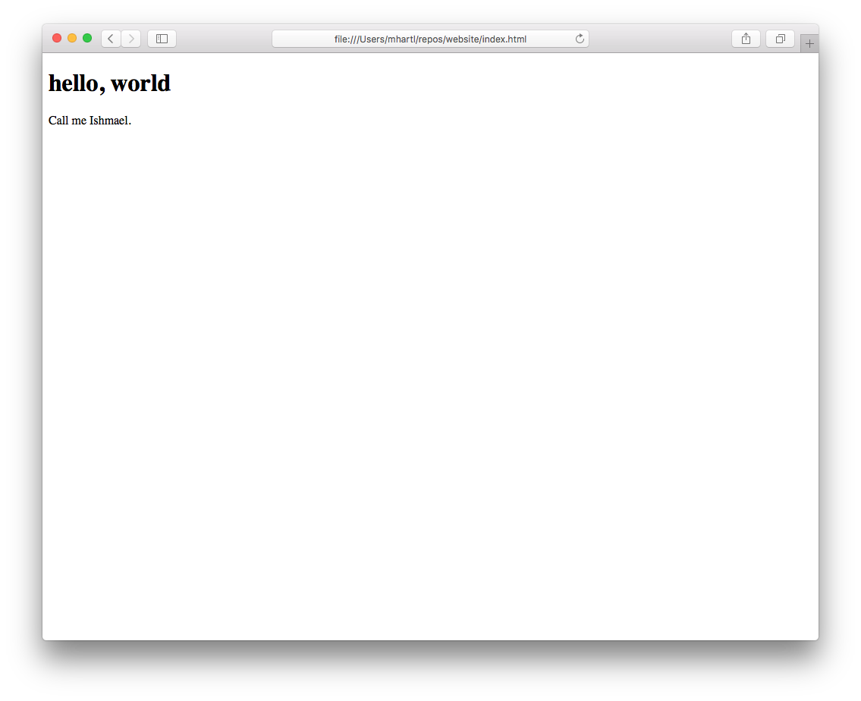

Figure 1.7: Adding HTML structure makes hardly any difference in the appearance.

Since we haven’t added any files, using git commit -am suffices to commit all the changes ([Listing 1.8](https://www.learnenough.com/git-tutorial?single_page=1#code-commit_html_structure)).

Listing 1.8: The commit to add the HTML structure.

[website (master)]$ git commit -am "Add some HTML structure"

[**1.6.1 Exercises**](https://www.learnenough.com/git-tutorial?single_page=1#sec-exercises_adding_html_structure)

1. Add the title “A whale of a greeting” to index.html. Browsers differ in how they display titles; the result in Google Chrome is shown in [Figure 1.8](https://www.learnenough.com/git-tutorial?single_page=1#fig-page_title).
2. Commit the new title with a commit message of your choice. Verify using git log -p that the change was committed as expected.
3. By pasting the contents of [Listing 1.6](https://www.learnenough.com/git-tutorial?single_page=1#code-html_structure) into an [HTML validator](https://validator.w3.org/#validate_by_input), verify that it is *not* (quite) a valid web page.
4. Using the validator, verify that the current index.html (with nonblank page title) *is* valid.

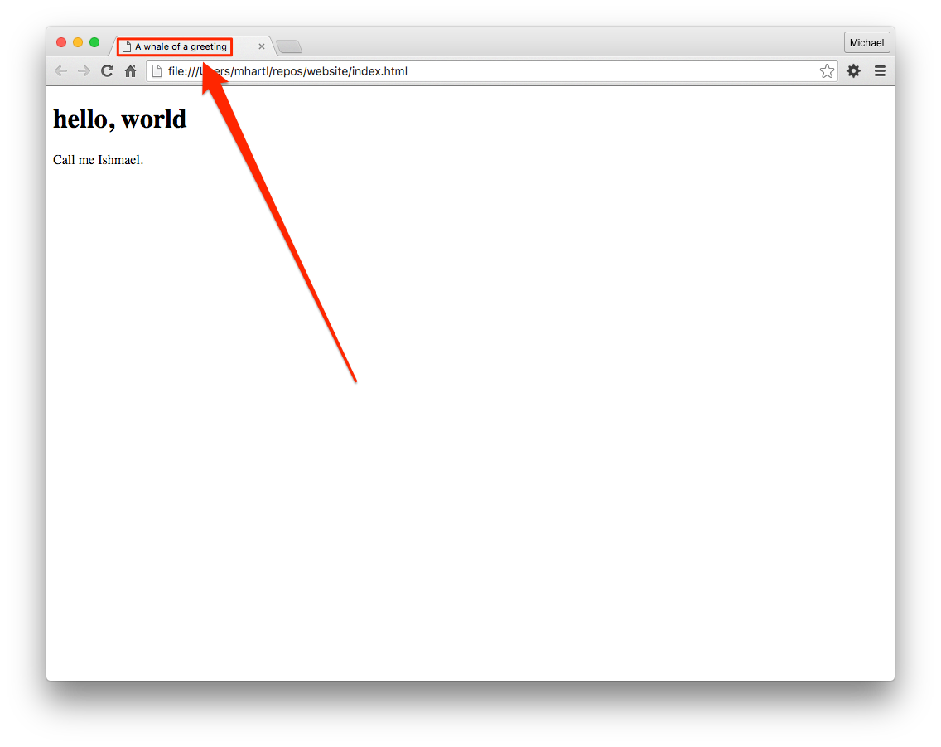

Figure 1.8: The page title displayed in a browser.

[**1.7 Summary**](https://www.learnenough.com/git-tutorial?single_page=1#sec-summary_getting_started)

Important commands from this section are summarized in [Table 1.1](https://www.learnenough.com/git-tutorial?single_page=1#table-getting_started).

|  |  |  |
| --- | --- | --- |
| **Command** | **Description** | **Example** |
| git help | Get help on a command | $ git help push |
| git config | Configure Git | $ git config --global … |
| source <file> | Activate Bash changes | $ source ~/.bash_profile |
| mkdir -p | Make intermediate directories as necessary | $ mkdir -p repos/website |
| git status | Show the status of the repository | $ git status |
| touch <name> | Create empty file | $ touch foo |
| git add -A | Add all files or directories to staging area | $ git add -A |
| git add <name> | Add given file or directory to staging area | $ git add foo |
| git commit -m | Commit staged changes with a message | $ git commit -m "Add thing" |
| git commit -am | Stage and commit changes with a message | $ git commit -am "Add thing" |
| git diff | Show diffs between commits, branches, etc. | $ git diff |
| git commit --amend | Amend the last commit | $ git commit --amend |
| git show <SHA> | Show diff vs. the SHA | $ git show fb738e… |

Table 1.1: Important commands from [Chapter 1](https://www.learnenough.com/git-tutorial?single_page=1#cha-getting_started).

[**Chapter 2 Backing up and sharing**](https://www.learnenough.com/git-tutorial?single_page=1#cha-sharing)

With the changes made in [Chapter 1](https://www.learnenough.com/git-tutorial?single_page=1#cha-getting_started), we’re now ready to push a copy of our project to a *remote repository*. This will serve as a backup of our project and its history, and will also make it easier for collaborators to work with us on our site.

We’ll start by pushing our project up to *GitHub*, a site designed to facilitate collaboration with Git repositories. For repositories that are publicly available, GitHub is free, so we’ll plan to make our website’s repo public to take advantage of this. (When this tutorial was first written, GitHub charged for private repositories; in [Section 4.4.1](https://www.learnenough.com/git-tutorial?single_page=1#sec-exercises_surprise_bonus), we’ll discuss an [alternative](https://bitbucket.org/) that has always allowed unlimited free private repos.) Over time, releasing projects publicly on GitHub serves to build up a portfolio, which is one good reason to make as much work public as possible. There’s also a Secret Reason™ for adding our repo to GitHub, which we’ll get to in [Section 4.4](https://www.learnenough.com/git-tutorial?single_page=1#sec-a_surprise_bonus).

For reference, important commands from this section are summarized in [Section 2.4](https://www.learnenough.com/git-tutorial?single_page=1#sec-summary_sharing).

[**2.1 Signing up for GitHub**](https://www.learnenough.com/git-tutorial?single_page=1#sec-github)

If you don’t already have a GitHub account, you can get started by visiting the [GitHub signup page](https://github.com/join) ([Figure 2.1](https://www.learnenough.com/git-tutorial?single_page=1#fig-join_github)) and following the instructions. Use your technical sophistication ([Box 1.2](https://www.learnenough.com/git-tutorial?single_page=1#aside-technical_sophistication)) if you get stuck.

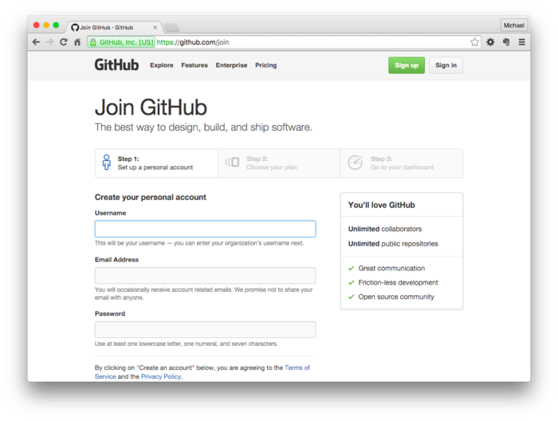

Figure 2.1: Joining GitHub.

Once you’ve signed up for GitHub, you’ll need to add *SSH keys* to your account, which serve as a way to identify trusted computers without requiring passwords.[1](https://www.learnenough.com/git-tutorial?single_page=1#cha-2_footnote-1) To do this, follow the steps in the GitHub article “[Generating SSH Keys](https://help.github.com/articles/generating-ssh-keys/)” ([Figure 2.2](https://www.learnenough.com/git-tutorial?single_page=1#fig-generating_ssh_keys)). This is a good application of the command-line knowledge from [*Learn Enough Command Line to Be Dangerous*](https://www.learnenough.com/command-line), and is an *excellent* exercise in technical sophistication. In particular, following the GitHub tutorial on generating SSH keys will help you develop an essential technical skill:

It’s important to be able to follow a series of commands *even if you don’t completely understand them*.

Even *I* don’t completely understand the commands at “[Generating SSH Keys](https://help.github.com/articles/generating-ssh-keys/)”, and that’s OK. All you need is enough technical sophistication to follow the steps (and resolve any errors that occur) even if you’re not 100% sure of what you’re doing ([Figure 2.3](https://www.learnenough.com/git-tutorial?single_page=1#fig-no_idea)).[2](https://www.learnenough.com/git-tutorial?single_page=1#cha-2_footnote-2)

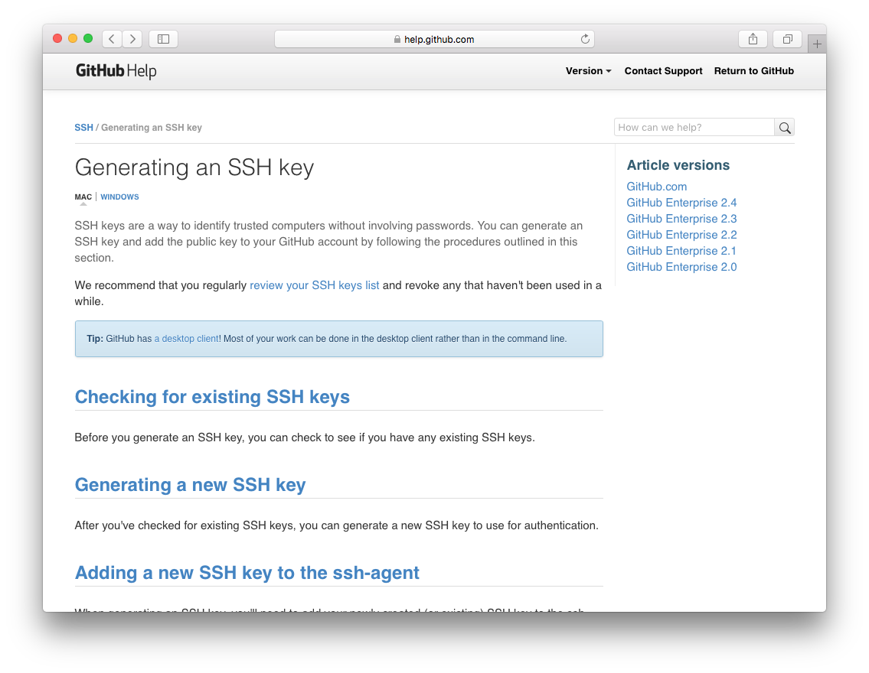

Figure 2.2: The GitHub tutorial on generating SSH keys.



Figure 2.3: It’s OK—neither does anyone else.

One neat thing about the GitHub SSH keys tutorial is that it detects the system you’re on and customizes the tutorial accordingly. For example, on my system (macOS), the SSH tutorial includes the step

$ pbcopy < ~/.ssh/id_rsa.pub

# Copies the contents of the id_rsa.pub file to your clipboard

which works only on a Mac. This customization is fine for most situations, but sometimes it will fail. For example, if you are on a Macintosh or Windows computer but are using the Linux virtual machine from [Box 1.3](https://www.learnenough.com/git-tutorial?single_page=1#aside-using_unix), you need the instructions for Linux, not for your native OS. In that case, either use a browser on the system for which you need instructions or look for menu items with links to the right platform ([Figure 2.4](https://www.learnenough.com/git-tutorial?single_page=1#fig-github_ssh_menu)).

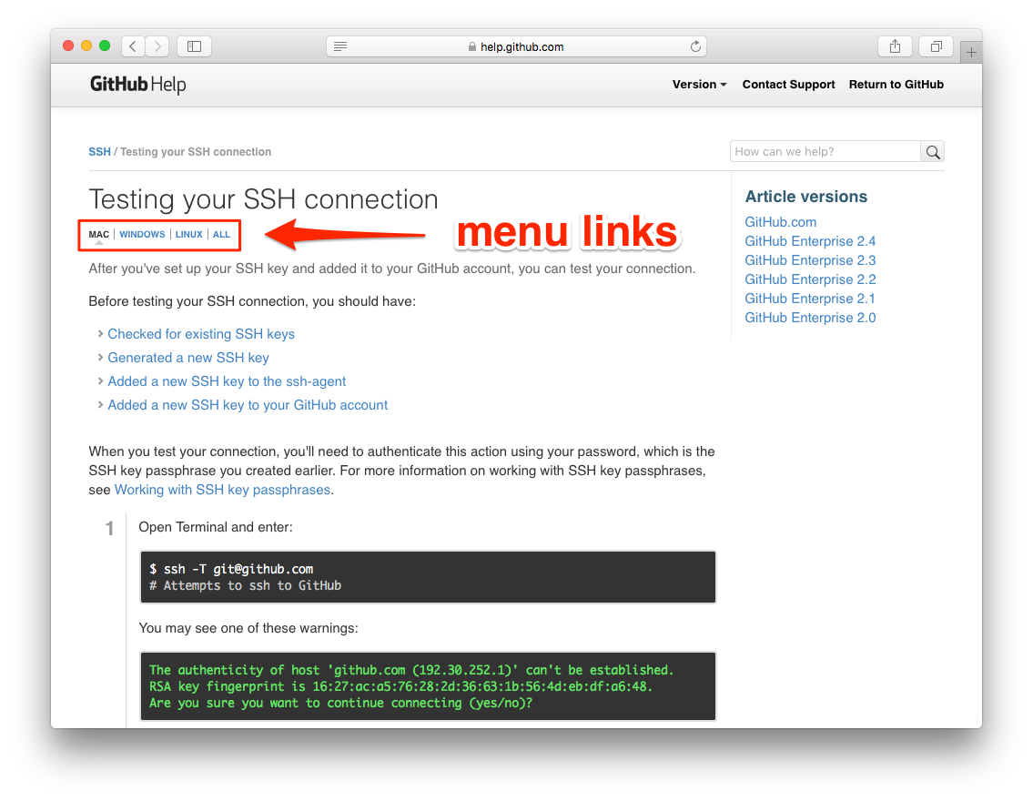

Figure 2.4: Menu links for the SSH tutorial on different systems.

[**2.1.1 Exercises**](https://www.learnenough.com/git-tutorial?single_page=1#sec-exercises_github)

1. Read the [SSH article on Wikipedia](https://en.wikipedia.org/wiki/Secure_Shell) until you finish it or run out of motivation to continue.

[**2.2 Remote repo**](https://www.learnenough.com/git-tutorial?single_page=1#sec-remote_repo)

After signing up for a GitHub account, the next step is to create a remote repository. Start by selecting the menu item for adding a new repository, as shown in [Figure 2.5](https://www.learnenough.com/git-tutorial?single_page=1#fig-add_new_repository), and then fill in the repository name (“website”) and description (“A sample website for Learn Enough Git to Be Dangerous”) as shown in [Figure 2.6](https://www.learnenough.com/git-tutorial?single_page=1#fig-create_a_new_repository). GitHub actively develops its user interface, so [Figure 2.5](https://www.learnenough.com/git-tutorial?single_page=1#fig-add_new_repository), [Figure 2.6](https://www.learnenough.com/git-tutorial?single_page=1#fig-create_a_new_repository), and other GitHub screenshots may not match your results exactly, but this is no cause for concern. As usual, apply your technical sophistication ([Box 1.2](https://www.learnenough.com/git-tutorial?single_page=1#aside-technical_sophistication)) to resolve any discrepancies.

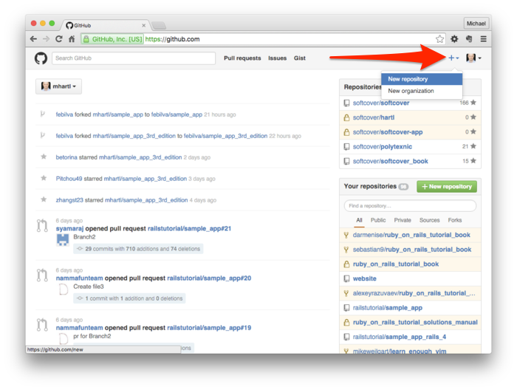

Figure 2.5: Adding a new repository at GitHub.

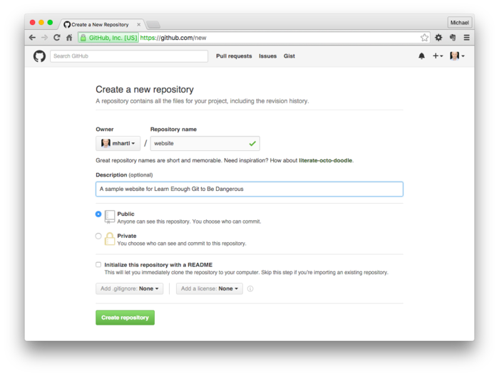

Figure 2.6: Creating a new repository.

After clicking the green “Create repository” button seen in [Figure 2.6](https://www.learnenough.com/git-tutorial?single_page=1#fig-create_a_new_repository), you should see a page like [Figure 2.7](https://www.learnenough.com/git-tutorial?single_page=1#fig-pushing_up_repo) containing instructions for how to *push* your local repository up to GitHub. The exact commands will be tailored to your personal account name; the template looks like [Listing 2.1](https://www.learnenough.com/git-tutorial?single_page=1#code-github_push_template). (It is not important to understand these commands at this time.)

Listing 2.1: A template for the first push to GitHub.

[website (master)]$ git remote add origin https://github.com/<name>/website.git

[website (master)]$ git push -u origin master

Of course, you should replace <name> with your actual username. For example, the commands for my username, which is mhartl, look like this (which you can also see in [Figure 2.7](https://www.learnenough.com/git-tutorial?single_page=1#fig-pushing_up_repo)):

[website (master)]$ git remote add origin https://github.com/mhartl/website.git

[website (master)]$ git push -u origin master

If you’re on macOS and you ever have trouble pushing to GitHub without having to re-enter your password every time, take a look at [Caching your GitHub password in Git](https://help.github.com/articles/caching-your-github-password-in-git/) to learn about the git-osxkeychain helper.

The two commands in [Listing 2.1](https://www.learnenough.com/git-tutorial?single_page=1#code-github_push_template) first set GitHub as the *remote origin* and then *push* the full repository. The -u option to git push sets GitHub as the *upstream repository*, which means we’ll be able to download any changes automatically when we run git pull starting in [Section 4.1](https://www.learnenough.com/git-tutorial?single_page=1#sec-clone_push_pull). Don’t worry about these details, though; you will almost always copy such commands from GitHub and probably won’t ever have to figure them out on your own.

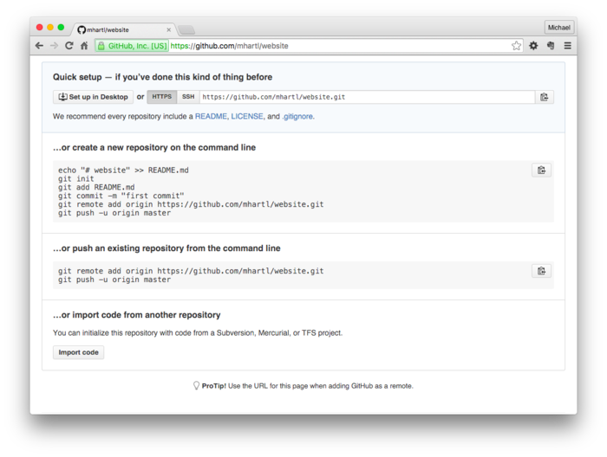

Figure 2.7: Instructions for pushing up the repo.

After executing the first git push as shown in [Listing 2.1](https://www.learnenough.com/git-tutorial?single_page=1#code-github_push_template), you should reload the current page (using, e.g., ⌘R or the icon shown in [Figure 2.8](https://www.learnenough.com/git-tutorial?single_page=1#fig-reload_page)). The result should look something like [Figure 2.9](https://www.learnenough.com/git-tutorial?single_page=1#fig-remote_repo). If it does, you have officially shipped your first Git repository!



Figure 2.8: The browser reload page button.

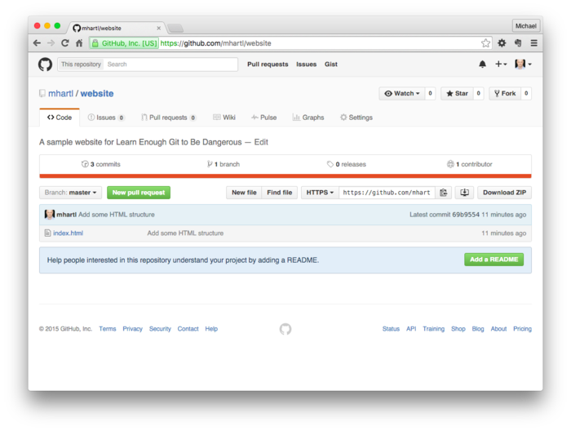

Figure 2.9: The remote repository at GitHub.

[**2.2.1 Exercises**](https://www.learnenough.com/git-tutorial?single_page=1#sec-exercises_remote_repo)

1. On the GitHub page for your repo, click on “Commits” to see a list of your commits. Confirm that they match the results of running git log on your local system.
2. At GitHub, click on the commit for adding HTML structure ([Listing 1.8](https://www.learnenough.com/git-tutorial?single_page=1#code-commit_html_structure)). Verify that the diff for the commit agrees with the one shown in [Listing 1.7](https://www.learnenough.com/git-tutorial?single_page=1#code-diff_html_structure).
3. In honor of shipping your first Git repo, drink a celebratory beverage of your choice ([Figure 2.10](https://www.learnenough.com/git-tutorial?single_page=1#fig-celebratory_beverage)).[3](https://www.learnenough.com/git-tutorial?single_page=1#cha-2_footnote-3)



Figure 2.10: Shipping a project often calls for a celebratory beverage.

[**2.3 Adding a README**](https://www.learnenough.com/git-tutorial?single_page=1#sec-adding_a_readme)

Now that we’ve pushed up our repository, let’s add a second file and practice the add, commit, and push sequence shown in [Figure 1.1](https://www.learnenough.com/git-tutorial?single_page=1#fig-git_status_sequence). You may have noticed in [Figure 2.9](https://www.learnenough.com/git-tutorial?single_page=1#fig-remote_repo) that GitHub encourages the presence of a README file via the note “Help people interested in this repository understand your project by adding a README.” Such a file literally asks the viewer to “READ ME”, *à la* the DRINK ME bottle from [*Alice’s Adventures in Wonderland*](https://www.cs.indiana.edu/metastuff/wonder/ch1.html) ([Figure 2.11](https://www.learnenough.com/git-tutorial?single_page=1#fig-drink_me)),[4](https://www.learnenough.com/git-tutorial?single_page=1#cha-2_footnote-4) and it’s a good practice to include one.

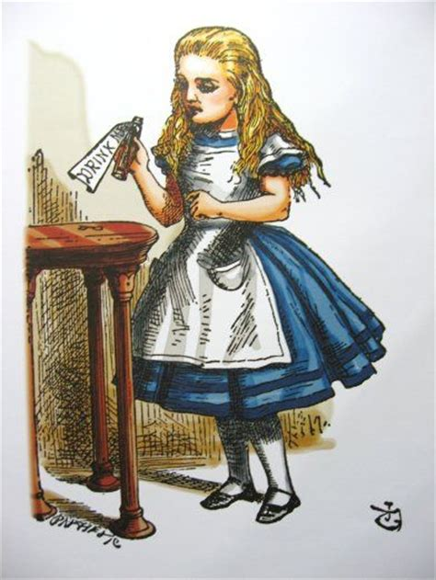

Figure 2.11: Alice would know to read a README file.

[Figure 2.9](https://www.learnenough.com/git-tutorial?single_page=1#fig-remote_repo) shows a green Add a README button that GitHub includes to make it easy to add a README file through the web interface, but we’ll follow the common (and more instructive) practice of adding it by hand locally and then pushing it up. When it comes to rendering and displaying READMEs, GitHub supports several common formats, but my favorite format for short documents like READMEs is Markdown, a lightweight markup language [discussed before](https://www.learnenough.com/r/learn_enough_text_editor/modern_text_editors/opening#sec-opening) in [*Learn Enough Text Editor to Be Dangerous*](https://www.learnenough.com/text-editor).

We can get started by opening README.md in Atom (or any other text editor), where the .md extension identifies the file as Markdown:

[website (master)]$ atom README.md

We can then fill it with the content shown in [Listing 2.2](https://www.learnenough.com/git-tutorial?single_page=1#code-readme).

Listing 2.2: The contents of the README file. ~/repos/website/README.md

# Sample Website

This is a sample website made as part of [*Learn Enough™ Git to Be

Dangerous*](https://www.learnenough.com/git-tutorial), possibly the greatest

beginner Git tutorial in the history of the Universe. You should totally [

check it out](https://www.learnenough.com/git-tutorial), and be sure to [join

the email list](https://www.learnenough.com/#email_list) and

[follow @learnenough](http://twitter.com/learnenough) on Twitter.

After finishing *Learn Enough™ Git to Be Dangerous*, you'll know enough Git

to be *dangerous*. This means you'll be able to use Git to track changes in

your projects, back up data, share your work with others, and collaborate

with programmers and other users of Git.

The result in Atom appears as shown in [Figure 2.12](https://www.learnenough.com/git-tutorial?single_page=1#fig-atom_readme). As [mentioned](https://www.learnenough.com/r/learn_enough_text_editor/modern_text_editors/opening#sec-previewing_markdown) in [*Learn Enough Text Editor to Be Dangerous*](https://www.learnenough.com/text-editor), Atom includes a Markdown previewer via the Packages menu item shown in [Figure 2.13](https://www.learnenough.com/git-tutorial?single_page=1#fig-markdown_preview_menu), which (after resizing the window) results in the preview shown in [Figure 2.14](https://www.learnenough.com/git-tutorial?single_page=1#fig-atom_markdown_preview).[5](https://www.learnenough.com/git-tutorial?single_page=1#cha-2_footnote-5)

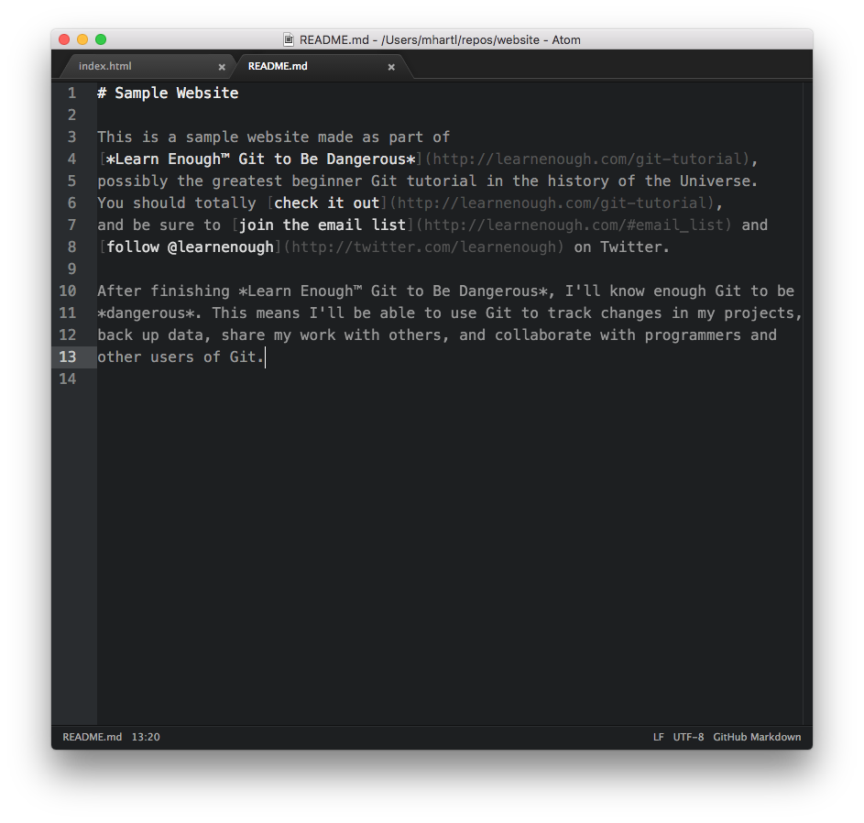

Figure 2.12: The README file viewed in Atom.

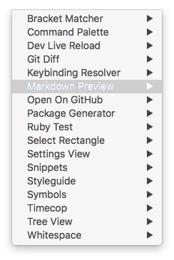

Figure 2.13: The Packages menu item for toggling the Markdown preview.

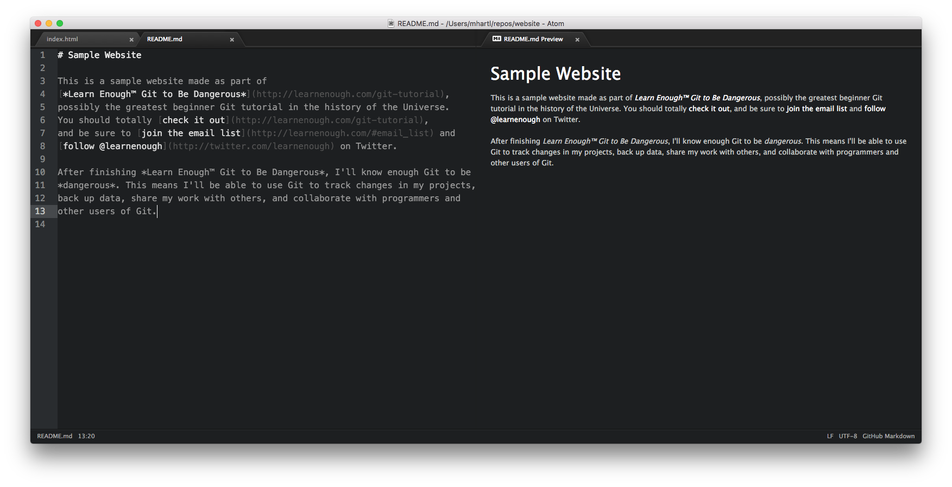

Figure 2.14: The resized Atom window with a Markdown preview.

Now that we’ve created the README.md file, we’re ready to add it to our Git repository and push it up. We can’t just run git commit -am because README.md isn’t currently in the repository, so we have to add it first:

[website (master)]$ git add -A

(As noted in [Section 1.3.1](https://www.learnenough.com/git-tutorial?single_page=1#sec-exercises_our_first_commit), we could also run git add README.md, but in most cases we want to add all the new files, so I suggest getting in the habit of running git add -A unless there’s a specific reason not to.) Then we commit as usual:

[website (master)]$ git commit -m "Add README file"

By the way, there’s no harm in including -a via the -am combination shown in [Listing 1.5](https://www.learnenough.com/git-tutorial?single_page=1#code-git_commit_am) (and despite the redundancy I often do so out of habit), so this could just as easily read git commit -am "Add a README file". (The call to git add is still necessary, though; recall from [Section 1.4](https://www.learnenough.com/git-tutorial?single_page=1#sec-viewing_the_diff) that git commit -a by itself commits changes only to files that Git is already tracking and have been modified.)

Having added the file to the repository and made a commit, we’re now ready to push up to GitHub. Recall from [Listing 2.1](https://www.learnenough.com/git-tutorial?single_page=1#code-github_push_template) that the first occurrence of git push included the “set upstream” option -u, the destination origin, and master, but once these are set up we can omit all those details and just push, like this:

[website (master)]$ git push

The result of this is to push up the new README to the remote repository, which means that we’ve completed the full sequence shown in [Figure 1.1](https://www.learnenough.com/git-tutorial?single_page=1#fig-git_status_sequence). In this case, GitHub uses the .md extension to identify the file as Markdown, converting it to HTML for easy viewing,[6](https://www.learnenough.com/git-tutorial?single_page=1#cha-2_footnote-6) as shown in [Listing 2.2](https://www.learnenough.com/git-tutorial?single_page=1#code-readme).

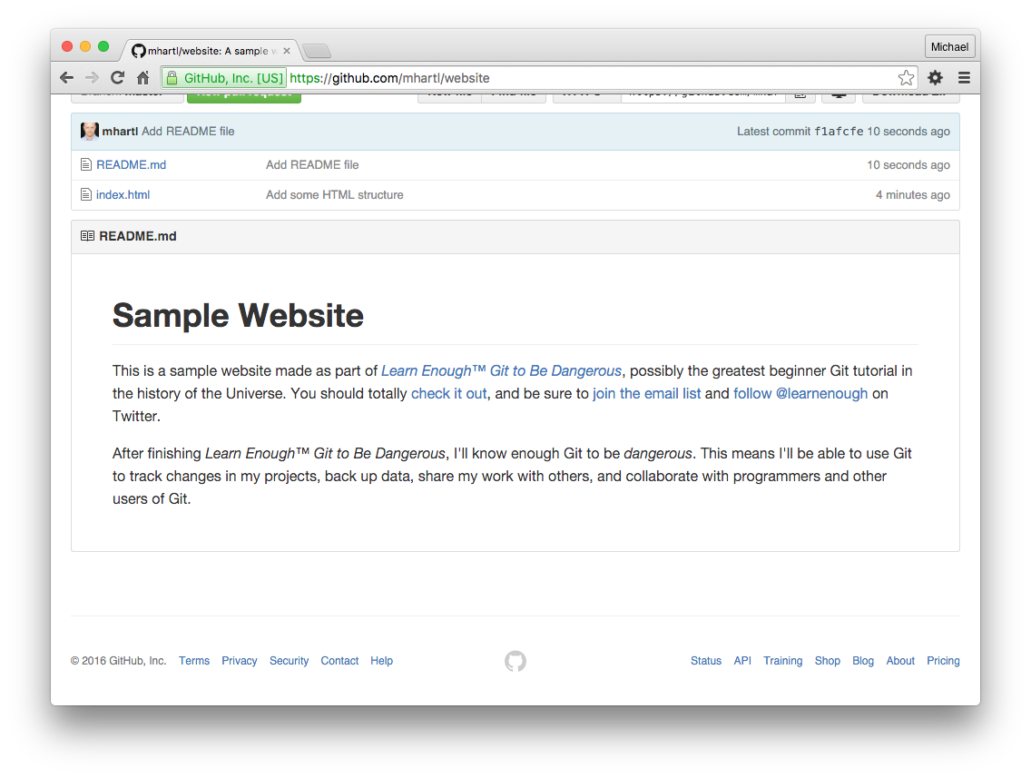

Figure 2.15: The README file at GitHub.

[**2.3.1 Exercises**](https://www.learnenough.com/git-tutorial?single_page=1#sec-exercises_adding_a_readme)

1. Using the Markdown shown in [Listing 2.3](https://www.learnenough.com/git-tutorial?single_page=1#code-official_git_documentation), add a line at the end of the README with a link to the official Git documentation.
2. Commit your change with an appropriate message ([Box 1.4](https://www.learnenough.com/git-tutorial?single_page=1#aside-commit_messages)). You don’t have to run git add. Why not?
3. Push your change to GitHub. By refreshing your browser, confirm that the new line has been added to the rendered README. Click on the “official Git documentation” link to verify that it works.

Listing 2.3: Markdown code for adding a link to the official Git documentation. ~/repos/website/README.md

For more information on Git, see the

[official Git documentation](https://git-scm.com/).

[**2.4 Summary**](https://www.learnenough.com/git-tutorial?single_page=1#sec-summary_sharing)

Important commands from this section are summarized in [Table 2.1](https://www.learnenough.com/git-tutorial?single_page=1#table-sharing).

|  |  |  |
| --- | --- | --- |
| **Command** | **Description** | **Example** |
| git remote add | Add remote repo | $ git remote add origin |
| git push -u <loc> <br> | Push branch to remote | $ git push -u origin master |
| git push | Push to default remote | $ git push |

Table 2.1: Important commands from [Chapter 2](https://www.learnenough.com/git-tutorial?single_page=1#cha-sharing).

[**Chapter 3 Intermediate workflow**](https://www.learnenough.com/git-tutorial?single_page=1#cha-intermediate_workflow)

In this section, we’ll practice and extend the basic workflow introduced in [Section 2.3](https://www.learnenough.com/git-tutorial?single_page=1#sec-adding_a_readme). This will include adding a new directory to our project, learning how to tell Git to ignore certain files, how to *branch* and *merge*, and how to recover from errors. Rather than providing an encyclopedic coverage of Git’s many commands, our focus is on covering practical techniques used every day by software developers and other users of Git.

For reference, important commands from this section are summarized in [Section 3.5](https://www.learnenough.com/git-tutorial?single_page=1#sec-summary_intermediate_workflow).

[**3.1 Commit, push, repeat**](https://www.learnenough.com/git-tutorial?single_page=1#sec-commit_push_repeat)

We’ll start by adding an image to our site, which involves making a change to an existing file (index.html) while adding a new file in a new directory. The first step is to make a directory for images:

[website (master)]$ mkdir images

Next, download the image shown in [Figure 3.1](https://www.learnenough.com/git-tutorial?single_page=1#fig-breaching_whale)[1](https://www.learnenough.com/git-tutorial?single_page=1#cha-3_footnote-1) to the local directory using curl:

$ curl -o images/breaching_whale.jpg -OL cdn.learnenough.com/breaching_whale.jpg



Figure 3.1: An image to include in our website.

We’re now ready to include the image in our index page using the *image tag* img. This is a new kind of HTML tag; before we had opening and closing tags like

<p>content</p>

but the image tag is different. Unlike tags like h1 and p, the img tag is a *void element* (also called a *self-closing tag*), which means that it starts with <img and ends with >:

<img src="path/to/file" alt="Description">

Note that img has no content between tags because there’s no “between”; instead, it has a path to the *source* of the image, indicated by src. An alternate syntax uses /> instead of > in order to conform to constraints of [XML](https://en.wikipedia.org/wiki/XML), a markup language related to HTML:

<img src="path/to/file" alt="Description" />

You might sometimes see this syntax instead of the plain >, but in HTML5 the two are [exactly equivalent](https://www.w3.org/TR/html5/syntax.html#void-elements).

By the way, in the example above the path path/to/file is *meta*, meaning that it talks *about* the path rather than referring to the literal path itself. In such cases, it’s important to use the actual path to the file. (Successfully navigating such meta usage is a good sign of increasing technical sophistication ([Box 1.2](https://www.learnenough.com/git-tutorial?single_page=1#aside-technical_sophistication)).) In this case, the path is images/breaching_whale.jpg, so the img tag in index.html should appear as shown in [Listing 3.1](https://www.learnenough.com/git-tutorial?single_page=1#code-img_tag). (This image tag is actually missing something important, which we’ll add in [Section 4.2](https://www.learnenough.com/git-tutorial?single_page=1#sec-merge_conflicts).)

Listing 3.1: Adding an image to the index page. ~/repos/website/index.html

<!DOCTYPE html>

<html>

<head>

<title>A whale of a greeting</title>

</head>

<body>

<h1>hello, world</h1>

<p>Call me Ishmael.</p>

<img src="images/breaching_whale.jpg">

</body>

</html>

Refreshing the browser then gives the result shown in [Figure 3.2](https://www.learnenough.com/git-tutorial?single_page=1#fig-website_with_image). (Note that [Listing 3.1](https://www.learnenough.com/git-tutorial?single_page=1#code-img_tag) includes the title tag content, thereby incorporating the solution to an exercise in [Section 1.6.1](https://www.learnenough.com/git-tutorial?single_page=1#sec-exercises_adding_html_structure).)

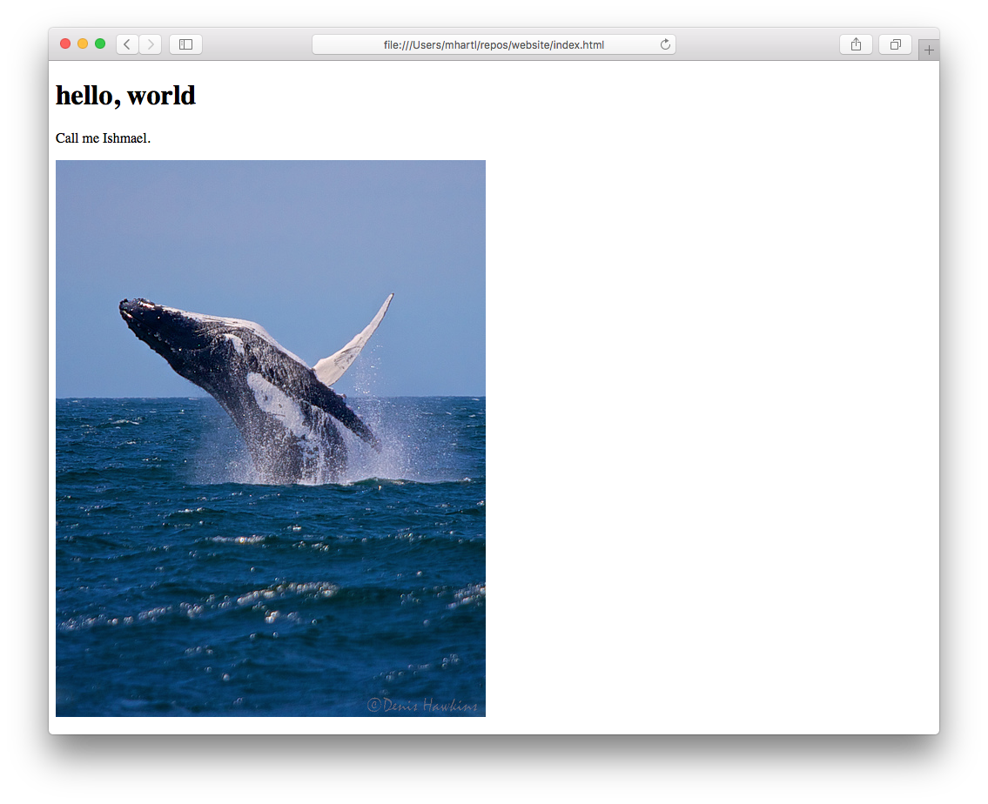

Figure 3.2: Our website with an added image.

At this point, git diff confirms that the image addition is ready to go:

[website (master)]$ git diff index.html

diff --git a/index.html b/index.html

index 706a1be..74043f7 100644

--- a/index.html

+++ b/index.html

@@ -6,5 +6,6 @@

<body>

<h1>hello, world</h1>

<p>Call me Ishmael.</p>

+ <img src="images/breaching_whale.jpg">

</body>

</html>

On the other hand, running git status shows that the entire images/ directory is untracked:

[website (master)]$ git status

On branch master

Your branch is up-to-date with 'origin/master'.

Changes not staged for commit:

(use "git add <file>..." to update what will be committed)

(use "git checkout -- <file>..." to discard changes in working directory)

modified: index.html

Untracked files:

(use "git add <file>..." to include in what will be committed)

images/

no changes added to commit (use "git add" and/or "git commit -a")

As you might guess, git add -A adds all untracked *directories* in addition to adding all untracked files, so we can add the image and its directory with a single command:

[website (master)]$ git add -A

We then commit and push as usual:

[website (master)]$ git commit -m "Add an image"

[website (master)]$ git push

It’s a good idea to get in the habit of pushing up to the remote repository frequently, as it serves as a guaranteed backup of the project while also allowing collaborators to pull in any changes ([Chapter 4](https://www.learnenough.com/git-tutorial?single_page=1#cha-collaborating)).

After refreshing the GitHub repository in your browser, you should be able to confirm the presence of the new file by clicking on the images directory link, with the results as shown in [Figure 3.3](https://www.learnenough.com/git-tutorial?single_page=1#fig-images_directory_on_github).

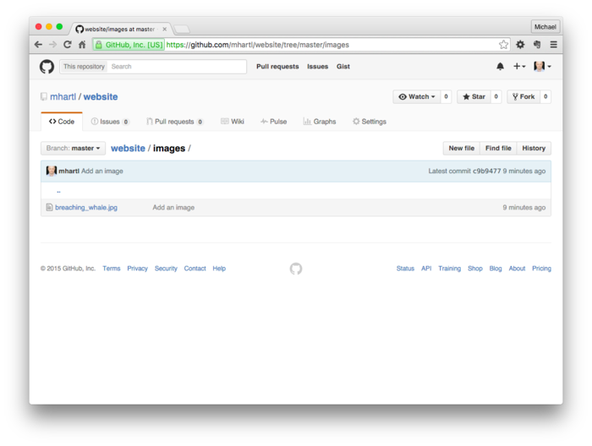

Figure 3.3: The new images directory on GitHub.

[**3.1.1 Exercises**](https://www.learnenough.com/git-tutorial?single_page=1#sec-exercises_commit_push_repeat)

1. Click on the image link at GitHub to verify that the git push succeeded.
2. At this point, the number of commits is large enough that the output of git log -p is probably too big to fit in your terminal window. Confirm that running git log -p drops you into a less interface for easier navigation.
3. Use your knowledge of [less commands](https://www.learnenough.com/r/learn_enough_command_line/inspecting_files/less_is_more#table-less_commands) to search for the commit that added the HTML DOCTYPE. What is the SHA of the commit?

[**3.2 Ignoring files**](https://www.learnenough.com/git-tutorial?single_page=1#sec-ignoring_files)

A frequent issue when dealing with Git repositories is coming across files you *don’t* want to commit. These include files containing secret credentials, configuration files that aren’t shared across computers, temporary files, log files, etc.

For example, on macOS a common side-effect of using the [Finder](https://support.apple.com/en-us/HT201732) to open directories is the creation of a hidden file called .DS_Store.[2](https://www.learnenough.com/git-tutorial?single_page=1#cha-3_footnote-2) In case you haven’t run into it yourself, we can simulate such a side-effect by using touch to create a sample .DS_Store file as follows:

[website (master)]$ touch .DS_Store

This file now shows up in the status:

[website (master)]$ git status

On branch master

Your branch is up-to-date with 'origin/master'.

Untracked files:

(use "git add <file>..." to include in what will be committed)

.DS_Store

nothing added to commit but untracked files present (use "git add" to track)

This is annoying, as we have no need to track this file, and indeed when collaborating with other users it could easily cause conflicts ([Section 4.2](https://www.learnenough.com/git-tutorial?single_page=1#sec-merge_conflicts)) down the line.

In order to avoid this annoyance, Git lets us *ignore* such files using a special hidden configuration file called .gitignore. To ignore .DS_Store, create a file called .gitignore using your favorite text editor and then fill it with the contents shown in [Listing 3.2](https://www.learnenough.com/git-tutorial?single_page=1#code-gitignore_ds_store).

Listing 3.2: Configuring Git to ignore a file. ~/repos/website/.gitignore

.DS_Store

After saving the contents of [Listing 3.2](https://www.learnenough.com/git-tutorial?single_page=1#code-gitignore_ds_store), the status now picks up the newly added .gitignore file, but it *doesn’t* list the .DS_Store file, thereby confirming that it’s being ignored:

[website (master)]$ git status

On branch master

Your branch is up-to-date with 'origin/master'.

Untracked files:

(use "git add <file>..." to include in what will be committed)

.gitignore

nothing added to commit but untracked files present (use "git add" to track)

This is an excellent start, but it would be inconvenient if we had to add the name of every file we want to ignore. For instance, the Vim text editor ([covered briefly](https://www.learnenough.com/r/learn_enough_text_editor/vim/mvv#sec-mvv) in [*Learn Enough Command Line to Be Dangerous*](https://www.learnenough.com/command-line)) sometimes creates *temporary files* whose names involve appending a tilde ~ to the end of the normal filename, so you might be editing a file called foo and end up with a file called foo~ in your directory. In such a case, we would want to ignore *all* files ending in a tilde. To support this case, the .gitignore file also lets us use *wildcards*, where the asterisk * represents “anything”:[3](https://www.learnenough.com/git-tutorial?single_page=1#cha-3_footnote-3)

*~

Adding the line above to .gitignore would cause all temporary Vim files to be ignored by Git. We can also add directories to .gitignore, so that, e.g.,

tmp/

would arrange to ignore all files in the tmp/ directory.

Git ignore files can get quite complicated, but in practice you can build them up over time by running git status and looking for any files or directories you don’t want to track, and then adding a corresponding pattern to the .gitignore file. In addition, many systems (such as the [Ruby on Rails](http://rubyonrails.org/) web framework and the [Softcover](http://www.softcover.io/) publishing platform) generate a good starting .gitignore file for you.[4](https://www.learnenough.com/git-tutorial?single_page=1#cha-3_footnote-4) See [Chapter 1](https://www.railstutorial.org/book/beginning#sec-first_time_setup) of the [*Ruby on Rails Tutorial*](https://www.railstutorial.org/book) for more information.

[**3.2.1 Exercises**](https://www.learnenough.com/git-tutorial?single_page=1#sec-exercises_ignoring_files)

1. Commit the .gitignore file to your repository. *Hint*: Running git commit -am isn’t enough. Why not?
2. Push your commit up to GitHub and confirm using the web interface that the push succeeded.

[**3.3 Branching and merging**](https://www.learnenough.com/git-tutorial?single_page=1#sec-branching_and_merging)

One of the most powerful features of Git is its ability to make *branches*, which are effectively complete self-contained copies of the project source, together with the ability to *merge* one branch into another, thereby incorporating the changes into the original branch. The best thing about a branch is that you can make your changes to the project in isolation from the master copy of the code, and then merge your changes in only when they’re done. This is especially helpful when collaborating with other users ([Chapter 4](https://www.learnenough.com/git-tutorial?single_page=1#cha-collaborating)); having a separate branch lets you make changes independently from other developers, reducing the risk of accidental conflicts.

We’ll use the addition of a second HTML page, an “About page”, as an example of how to use Git branches. Our first step is to use git checkout with the -b option, which makes a new branch called about-page and checks it out at the same time, as shown in [Listing 3.3](https://www.learnenough.com/git-tutorial?single_page=1#code-checkout_about_page).

Listing 3.3: Checking out and creating the about-page branch.

[website (master)]$ git checkout -b about-page

[website (about-page)]$

The prompt in [Listing 3.3](https://www.learnenough.com/git-tutorial?single_page=1#code-checkout_about_page) includes the new branch name for convenience, which is a result of the optional advanced setup in [Section 4.6.2](https://www.learnenough.com/git-tutorial?single_page=1#sec-prompt_branches_and_tab_completion), so your prompt may differ.

Now that we’ve checked out the new branch about-page branch, we can visualize our repository as shown in [Figure 3.4](https://www.learnenough.com/git-tutorial?single_page=1#fig-git_branch). The main repository evolution is a series of commits, and the branch effectively represents a copy of the repo at the time the branch was made.[5](https://www.learnenough.com/git-tutorial?single_page=1#cha-3_footnote-5) Our plan is to make a series of changes on the about-page branch, and then incorporate the changes back into the master branch using git merge.

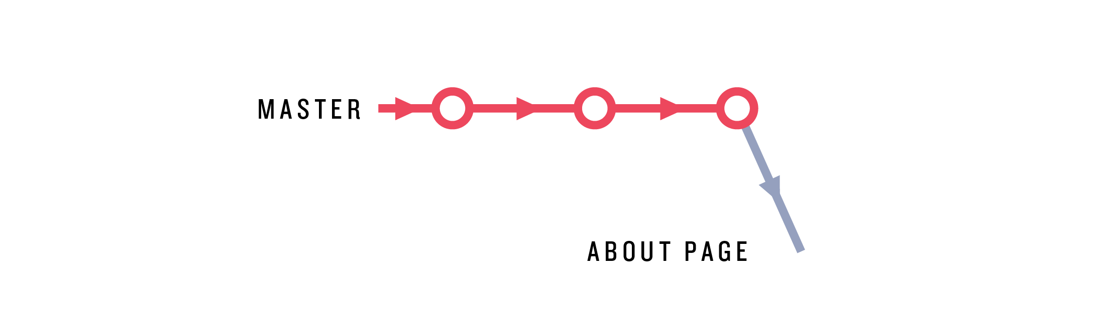

Figure 3.4: Branching off the master branch.

We can view the current branches using the git branch command:

[website (about-page)]$ git branch

* about-page

master

This lists all the branches currently defined on the local machine, with an asterisk * indicating the currently checked-out branch. (We’ll learn how to list *remote* branches in [Section 4.3](https://www.learnenough.com/git-tutorial?single_page=1#sec-pushing_branches).)

Having checked out the branch for the About page, we’re now ready to start making some changes to our working directory. We’ll start by making a new file called about.html to include some information about our project. Because we want the new page to have the full HTML structure (as in [Figure 1.7](https://www.learnenough.com/git-tutorial?single_page=1#fig-html_structure)), we’ll copy over the index.html file and then edit it as necessary:

[website (about-page)]$ cp index.html about.html

If this duplication seems a little unclean, it is. For example, what if there were an error in the HTML structure of index.html? Having copied it over to about.html, we’d have to make the correction in both places. As we’ll see in [Section 4.3](https://www.learnenough.com/git-tutorial?single_page=1#sec-pushing_branches), in fact there *is* an error, and we *will* have to make the correction twice. This sort of situation is annoying, and it’s far better to use a *site template* that avoids unnecessary duplication. We’ll start learning how to do that in [*Learn Enough CSS & Layout to Be Dangerous*](https://www.learnenough.com/css-and-layout).

Throughout the rest of the tutorial, we’ll be editing both index.html and about.html, so this is a good opportunity to use the preferred technique for opening a full project in a text editor (as [covered](https://www.learnenough.com/r/learn_enough_text_editor/advanced_text_editing/editing_projects#sec-editing_projects) in [*Learn Enough Text Editor to Be Dangerous*](https://www.learnenough.com/text-editor)). I suggest closing all current editor windows and re-opening the project as follows:

[website (about-page)]$ atom .

By doing this, we can use “[fuzzy opening](https://www.learnenough.com/r/learn_enough_text_editor/advanced_text_editing/editing_projects#sec-fuzzy_opening)” to open the files of our choice. In particular, in Atom we can use ⌘P to open about.html and start making the necessary changes.

After opening about.html, fill it with the contents shown in [Listing 3.4](https://www.learnenough.com/git-tutorial?single_page=1#code-about_html). As always, I recommend typing in everything by hand, which will make it easier to see the diffs relative to [Listing 3.1](https://www.learnenough.com/git-tutorial?single_page=1#code-img_tag). (The only possible exception is the trademark character ™, added to highlight character encoding issues, which you might have to copy and paste. On a Mac, you can get ™ using Option-2.)

Listing 3.4: The initial HTML for the About page. ~/repos/website/about.html

<!DOCTYPE html>

<html>

<head>

<title>About Us</title>

</head>

<body>

<h1>About</h1>

<p>

This site is a sample project for the <strong>awesome</strong> Git

tutorial <em>Learn Enough™ Git to Be Dangerous</em>.

</p>

</body>

</html>

[Listing 3.4](https://www.learnenough.com/git-tutorial?single_page=1#code-about_html) introduces two new tags: strong (which most browsers render as **boldface** text) and em for emphasis (which most browsers render as *italicized* text).

We’re now ready to commit the initial version of the About page. Because about.html is a new file, we have to add it and then commit, and I sometimes like to combine these two steps using && as [described](https://www.learnenough.com/r/learn_enough_command_line/directories/navigating_directories#aside-combining_commands) in [*Learn Enough Command Line to Be Dangerous*](https://www.learnenough.com/command-line):

[website (about-page)]$ git add -A && git commit -m "Add About page"

At this point, the about-page branch has diverged from master, as shown in [Figure 3.5](https://www.learnenough.com/git-tutorial?single_page=1#fig-about_page_branch_first_diff).



Figure 3.5: The about-page branch with a diff from master.

Before merging about-page back in to the master branch, we’ll make one more change. In the editor, use ⌘P or the equivalent to open index.html and add a *link* to the About page, as shown in [Listing 3.5](https://www.learnenough.com/git-tutorial?single_page=1#code-index_about_link).

Listing 3.5: Adding a link to the About page. ~/repos/website/index.html

<!DOCTYPE html>

<html>

<head>

<title>A whale of a greeting</title>

</head>

<body>

<h1>hello, world</h1>

<a href="about.html">About this project</a>

<p>Call me Ishmael.</p>

<img src="images/breaching_whale.jpg">

</body>

</html>

[Listing 3.5](https://www.learnenough.com/git-tutorial?single_page=1#code-index_about_link) uses the important (if confusingly named) *anchor tag* a, which is the HTML tag for making links. This tag contains both content (“About this project”) and a *hypertext reference*, or href, which in this case is the about.html file we just created. (Because about.html is on the same site as index.html, we can link to it directly, but when linking to external sites the href should be a fully qualified URL,[6](https://www.learnenough.com/git-tutorial?single_page=1#cha-3_footnote-6) such as <http://example.com/>.)[7](https://www.learnenough.com/git-tutorial?single_page=1#cha-3_footnote-7)

After saving the change and refreshing index.html in our browser, the result should appear as shown in [Figure 3.6](https://www.learnenough.com/git-tutorial?single_page=1#fig-link_to_about_page). Following the link should lead us to the About page, as seen in [Figure 3.7](https://www.learnenough.com/git-tutorial?single_page=1#fig-about_page_broken). Note that the trademark character ™ doesn’t display properly; we’ll fix this issue in [Section 4.3](https://www.learnenough.com/git-tutorial?single_page=1#sec-pushing_branches).

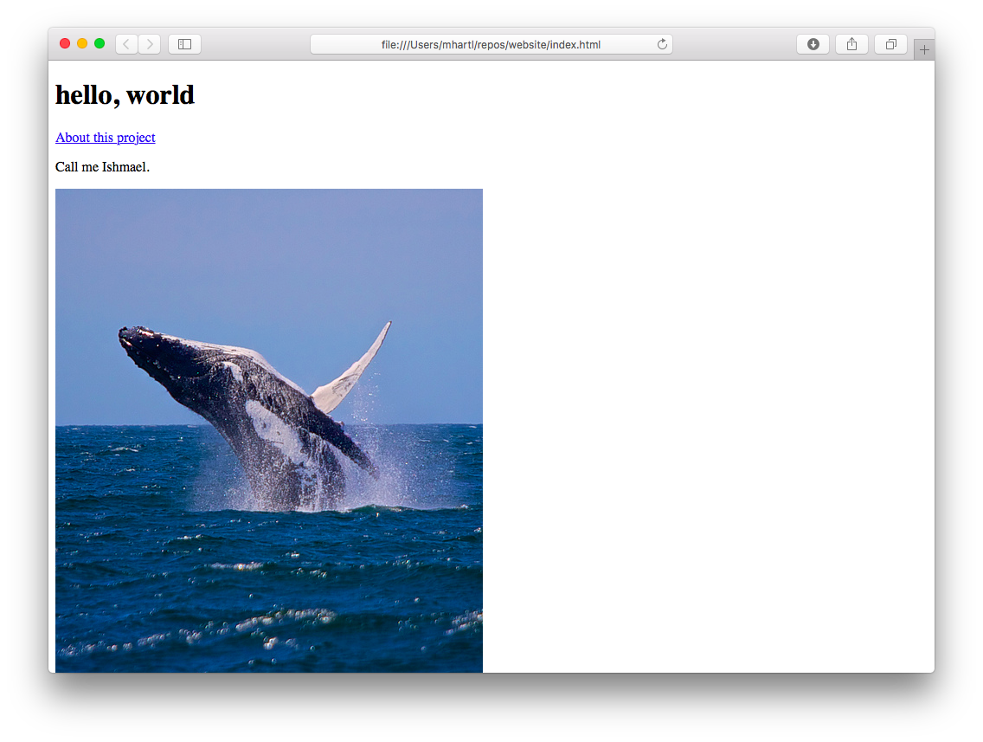

Figure 3.6: The index page with an added link.

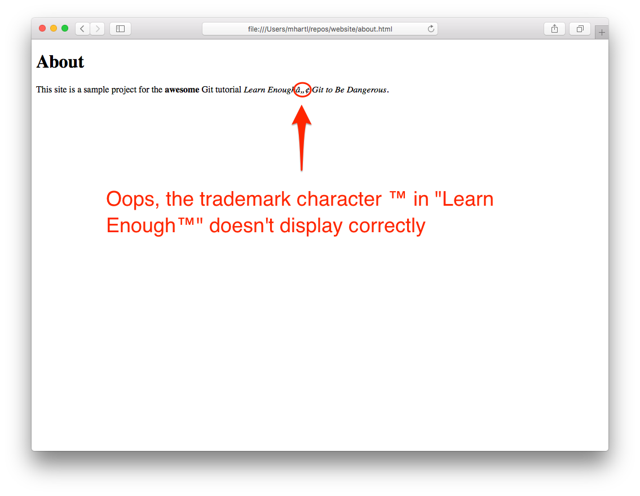

Figure 3.7: A slightly broken About page.

Having finished with the changes to index.html, we can make a commit as usual with git commit -am:

[website (about-page)]$ git commit -am "Add a link to the About page"

With this commit, the about-page branch now appears as in [Figure 3.8](https://www.learnenough.com/git-tutorial?single_page=1#fig-about_page_branch_index_changes).

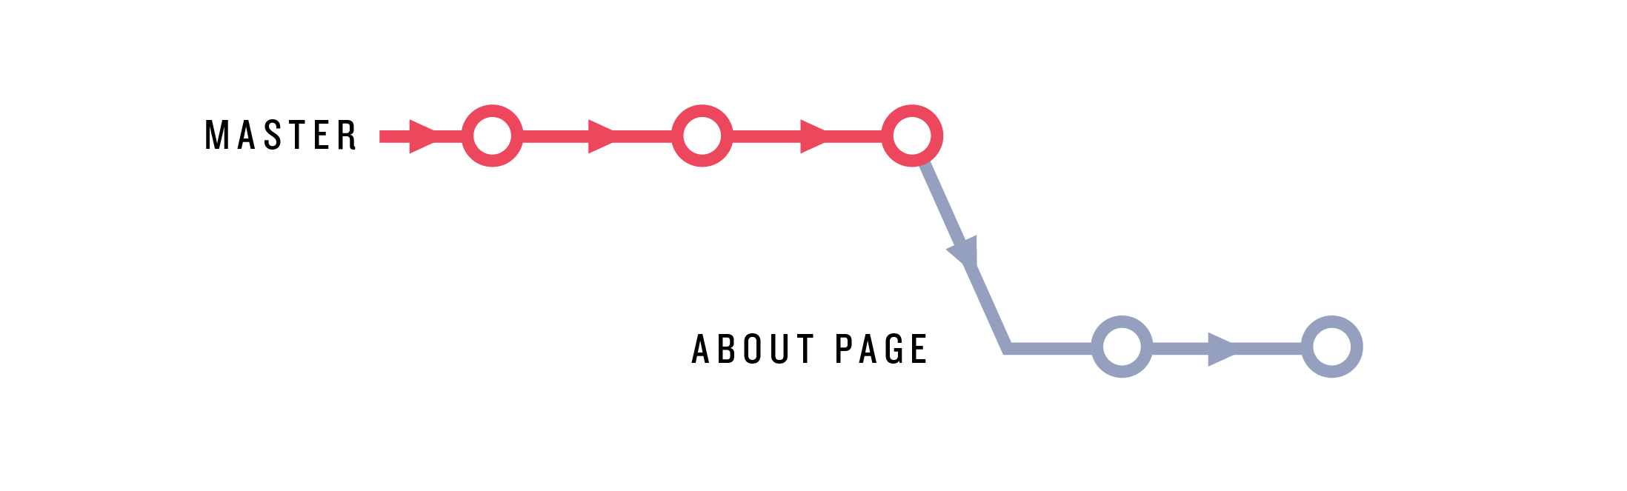

Figure 3.8: The current state of the about-page branch relative to master.

We’re done making changes for now, so we’re ready to merge the About page topic branch back into the master branch. We can get a handle on which changes we’ll be merging in by using git diff; we saw in [Section 1.4](https://www.learnenough.com/git-tutorial?single_page=1#sec-viewing_the_diff) that this command can be used by itself to see the difference between unstaged changes and our last commit, but the same command can be used to show diffs between branches. This can take the form git diff branch-1 branch-2, but if you leave the branch unspecified Git automatically diffs against the current branch. This means we can diff about-page vs. master as follows:

[website (about-page)]$ git diff master

The result in my terminal program appears as shown in [Figure 3.9](https://www.learnenough.com/git-tutorial?single_page=1#fig-git_diff_master). On my system, the diff is too long to fit on one screen, but (as we saw with git log in [Section 3.1.1](https://www.learnenough.com/git-tutorial?single_page=1#sec-exercises_commit_push_repeat)) the output of git diff uses the less program in this case.

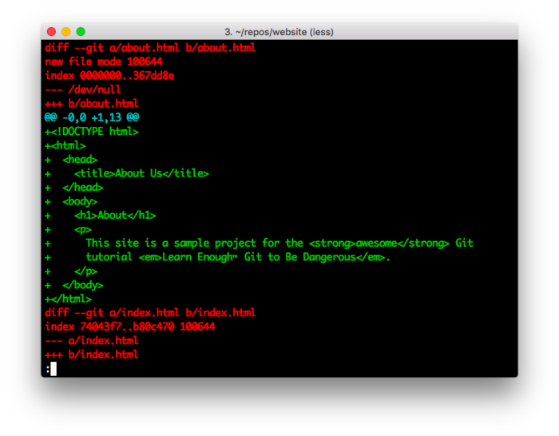

Figure 3.9: Diffing two branches.

To incorporate the changes on about-page into master, the first step is to check out the master branch:

[website (about-page)]$ git checkout master

[website (master)]$

Note that, unlike the checkout command in [Listing 3.3](https://www.learnenough.com/git-tutorial?single_page=1#code-checkout_about_page), here we omit the -b option because the master branch already exists.

The next step is to merge in the changes on the other branch, which we can do with git merge:

[website (master)]$ git merge about-page

At this point, our branch structure appears as in [Figure 3.10](https://www.learnenough.com/git-tutorial?single_page=1#fig-about_page_merged).

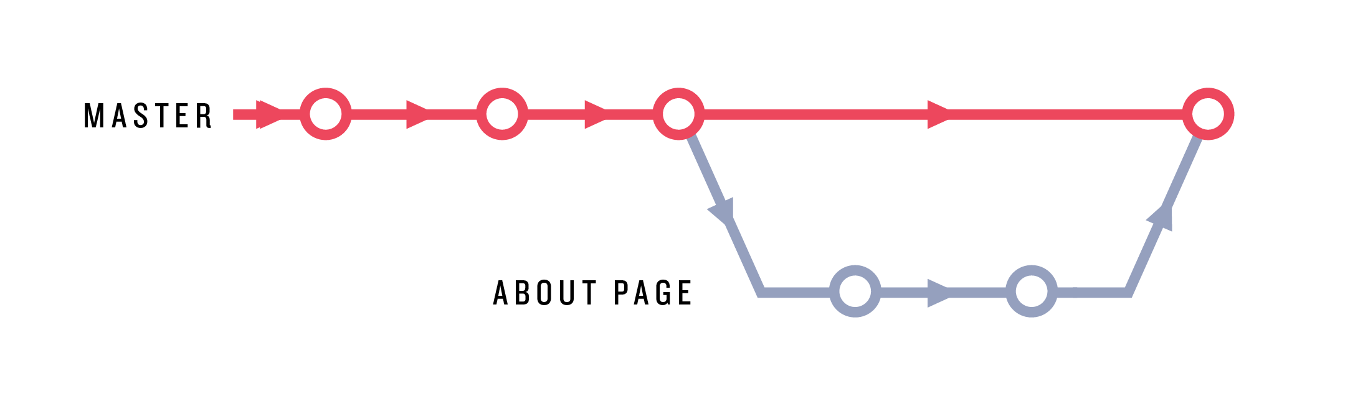

Figure 3.10: The branches after merging about-page into master.

In the present case, the master branch didn’t change while we were working on the about-page branch, but Git excels even when the original branch has changed in the interim. This situation is especially common when collaborating with others ([Chapter 4](https://www.learnenough.com/git-tutorial?single_page=1#cha-collaborating)), but can happen even when working alone. Suppose, for example, that we discovered a typo on master and wanted to fix it and push up immediately. In that case the master branch would change ([Figure 3.11](https://www.learnenough.com/git-tutorial?single_page=1#fig-master_branch_change)), but we could still merge in the topic branch as usual. There is a possibility that changes on master would *conflict* with the merged changes, but Git is good at automatically merging content. Even when conflict is unavoidable, Git is good at marking conflicts explicitly so that we can resolve them by hand. We’ll see a concrete example of this in [Section 4.2](https://www.learnenough.com/git-tutorial?single_page=1#sec-merge_conflicts).

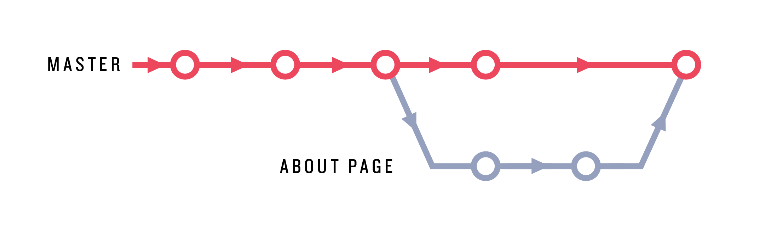

Figure 3.11: The tree structure if we made a change to master.

Having merged in the changes, we can sync up the local master branch with the version at GitHub (called origin/master) as usual:

[website (master)]$ git push

Since we probably don’t need the about-page branch any longer, we can optionally delete it, which is left as an exercise ([Section 3.3.2](https://www.learnenough.com/git-tutorial?single_page=1#sec-exercises_branching_and_merging)).

[**3.3.1 Rebasing**](https://www.learnenough.com/git-tutorial?single_page=1#sec-rebasing)

The most common way to combine branches is git merge, but there’s a second method called git rebase that you’re likely to encounter at some point. My advice for now is: *ignore git rebase*. The differences between merging and rebasing are subtle, and conventions for using rebase differ, so I recommend using git rebase only when an advanced Git user tells you to; otherwise, use git merge to combine the contents of two branches.

[**3.3.2 Exercises**](https://www.learnenough.com/git-tutorial?single_page=1#sec-exercises_branching_and_merging)

1. Use the command git branch -d about-page to delete the topic branch. Confirm by running git branch that only the master branch is left.
2. In [Listing 3.3](https://www.learnenough.com/git-tutorial?single_page=1#code-checkout_about_page), we used git checkout -b to create a branch and check it out at the same time, but it’s also possible to break this into two steps. As a first step, use git branch to make a branch with the name test-branch. (This involves passing an argument to git branch, as in git branch <branch name>.) Then confirm that the new branch exists but isn’t currently checked out by running git branch without an argument.
3. Check out test-branch and use touch to add a file with a name of your choice, then add and commit it to the repository.
4. Check out the master branch and try deleting the test branch using git branch -d to confirm that it doesn’t work. The reason is that, in contrast to the about-page branch, the test branch hasn’t been merged into master, and by design -d doesn’t work in this case. Because we don’t actually want its changes, delete the test by using the related -D option, which deletes the branch in question even if its changes are unmerged.

[**3.4 Recovering from errors**](https://www.learnenough.com/git-tutorial?single_page=1#sec-recovering_from_errors)

One of the most useful features of Git is its ability to let us recover from errors that would otherwise be catastrophic. The error-recovery techniques themselves can be dangerous, though, so they should always be implemented with care.

Let’s consider a common scenario where we make an unintentional change to a project and want to get back to the state of the repository as of the most recent commit (a state known as HEAD). For example, it’s a good practice to include a [newline](https://en.wikipedia.org/wiki/Newline) at the end of a file so that, e.g., running tail[8](https://www.learnenough.com/git-tutorial?single_page=1#cha-3_footnote-8) gives

[website (master)]$ tail about.html

.

.

.

</body>

</html>

[website (master)]$

instead of

[website (master)]$ tail about.html

.

.

.

</body>

</html>[website (master)]$

Of course, we could add such a newline using a text editor, but a common Unix idiom to accomplish the same thing is to use echo with the append operator >>:

[website (master)]$ echo >> about.html # Appends a newline to about.html

Unfortunately, in this context it’s easy to accidentally leave off one of the angle brackets and inadvertently use the *redirect* operator > instead:[9](https://www.learnenough.com/git-tutorial?single_page=1#cha-3_footnote-9)

[website (master)]$ echo > about.html

Go ahead and try the command above; you will discover that the result is to overwrite about.html with a newline, thereby effectively wiping out its contents, as we can verify with cat:

[website (master)]$ cat about.html

[website (master)]$

In a regular [Unix directory](https://www.learnenough.com/r/learn_enough_command_line/directories#cha-directories), there would be no hope of recovering the contents of about.html, but in a Git repository we can undo the changes by forcing the system to check out the most recently committed version. We start by confirming that about.html has changed by running git status:

[website (master)]$ git status

On branch master

Your branch is up-to-date with 'origin/master'.

Changes not staged for commit:

(use "git add <file>..." to update what will be committed)

(use "git checkout -- <file>..." to discard changes in working directory)

modified: about.html

no changes added to commit (use "git add" and/or "git commit -a")

This doesn’t indicate the scope of the damage, though, which we can inspect using git diff:

diff --git a/about.html b/about.html

index 6278cf6..8b13789 100644

--- a/about.html

+++ b/about.html

@@ -1,13 +1 @@

-<!DOCTYPE html>

-<html>

- <head>

- <title>About Us</title>

- </head>

- <body>

- <h1>About</h1>

- <p>

- This site is a sample project for the <strong>awesome</strong> Git

- tutorial <em>Learn Enough™ Git to Be Dangerous</em>.

- </p>

- </body>

-</html>

Those minus signs indicate that all of the lines of content are now gone. Happily, we can undo these changes by passing the -f (force) option to checkout, which forces Git to check out HEAD:[10](https://www.learnenough.com/git-tutorial?single_page=1#cha-3_footnote-10)

[website (master)]$ git checkout -f

We can then confirm that the About page has been restored:

[website (master)]$ git status

On branch master

Your branch is up-to-date with 'origin/master'.

nothing to commit, working directory clean

The status “working directory clean” indicates that there are no changes, and you can verify by running cat about.html that its contents have been restored. Phew! That was a close one. (It’s worth noting that git checkout -f itself is potentially dangerous, as it wipes out *all* the changes you’ve made, so use this trick only when you’re 100% sure you want to revert to HEAD.)

Another source of robustness against error is using branches, as described in [Section 3.3](https://www.learnenough.com/git-tutorial?single_page=1#sec-branching_and_merging). Because changes made on one branch are isolated from other branches, you can always just delete the branch if things go horribly wrong. For example, suppose we made the same echo mistake on a test-branch:

[website (master)]$ git checkout -b test-branch

[website (test-branch)]$ echo > about.html

We can fix this by committing the changes and then deleting the branch:

[website (test-branch)]$ git commit -am "Oops"

[website (test-branch)]$ git checkout master

[website (master)]$ git branch -D test-branch

Note here that we need to use -D instead of -d to delete the branch because test-branch is unmerged ([Section 3.3.2](https://www.learnenough.com/git-tutorial?single_page=1#sec-exercises_branching_and_merging)).

A final example of recovering from error involves the common case of a bug or other defect that makes its way into a project, origins unknown. In such a case, it’s convenient to be able to check out an earlier version of the repository.[11](https://www.learnenough.com/git-tutorial?single_page=1#cha-3_footnote-11) The way to do this is to use the SHAs from the Git log ([Section 1.3](https://www.learnenough.com/git-tutorial?single_page=1#sec-our_first_commit)). For example, to restore the website project to the state right after the second commit, we would run git log and navigate to the beginning of the log. Because git log uses the less interface, we can do this by typing G to go to the last line of the log.[12](https://www.learnenough.com/git-tutorial?single_page=1#cha-3_footnote-12) The result on my system is shown in [Listing 3.6](https://www.learnenough.com/git-tutorial?single_page=1#code-git_log_shas). (Because SHAs are by design unique identifiers, your values will differ.)

Listing 3.6: Viewing the SHAs in the Git log.

[website (master)]$ git log

commit 8c19674468a67720b9ba61a783e81f97062874bf

Author: Michael Hartl <michael@michaelhartl.com>

Date: Mon Dec 21 21:27:56 2015 -0800

Add a README

commit 69b955490caf12552e83d476820d29475fa35010

Author: Michael Hartl <michael@michaelhartl.com>

Date: Mon Dec 21 21:02:20 2015 -0800

Add some HTML structure

commit 03aff34ec4f9690228e057a4252bcca169a868b4

Author: Michael Hartl <michael@michaelhartl.com>

Date: Thu Dec 17 20:03:33 2015 -0800

Add content to index.html

commit 879392a6bd8dd505f21876869de99d73f40299cc

Author: Michael Hartl <michael@michaelhartl.com>

Date: Thu Dec 17 20:00:34 2015 -0800

Initialize repository

To check out the commit with the message “Add content to index.html”, simply copy the SHA and check it out:

[website (master)]$ git checkout 03aff34ec4f9690228e057a4252bcca169a868b4

Note: checking out '03aff34ec4f9690228e057a4252bcca169a868b4'.

You are in 'detached HEAD' state. You can look around, make experimental

changes and commit them, and you can discard any commits you make in this

state without impacting any branches by performing another checkout.

If you want to create a new branch to retain commits you create, you may

do so (now or later) by using -b with the checkout command again. Example:

git checkout -b new_branch_name

HEAD is now at 03aff34... Add content to index.html

[website ((03aff34...))]$

Note that the branch name in the last line has changed to reflect the value of the SHA, and Git has issued a warning that we are in a ‘detached HEAD’ state. I recommend using this technique to inspect the state of the project and figure out any necessary changes, then check out the master branch to apply them:

[website ((03aff34...))]$ git checkout master

[website (master)]$

At this point, you could switch to your text editor and make any necessary changes (such as fixing a bug discovered on the earlier commit).

If all this seems a little abstract, don’t worry. The main takeaways are (1) it’s possible to “go back in history” to view the project at an earlier state and (2) it’s tricky to make changes, so if you find yourself doing anything complicated you should ask a more experienced Git user what to do. (In particular, the exact practices in such a case could be team-dependent.)

[**3.4.1 Exercises**](https://www.learnenough.com/git-tutorial?single_page=1#sec-exercises_recovering_from_errors)

1. The git checkout -f trick works only with files that are staged for commit or are already part of the repository, but sometimes you want to get rid of new files as well. Using touch, create a file with a name of your choice, then git add it. Verify that running git checkout -f gets rid of it.
2. Like many other Unix programs, git accepts both “short form” and “long form” options. Repeat the previous exercise with git checkout --force to confirm that the effects of -f and --force are identical. *Extra credit*: Double-check this conclusion by finding the “force” option in the output of git help checkout.

[**3.5 Summary**](https://www.learnenough.com/git-tutorial?single_page=1#sec-summary_intermediate_workflow)

Important commands from this section are summarized in [Table 3.1](https://www.learnenough.com/git-tutorial?single_page=1#table-intermediate_workflow).

|  |  |  |
| --- | --- | --- |
| **Command** | **Description** | **Example** |
| .gitignore | Tell Git which things to ignore | $ echo .DS_store >> .gitignore |
| git checkout <br> | Check out a branch | $ git checkout master |
| git checkout -b <br> | Check out & create a branch | $ git checkout -b about-page |
| git branch | Display local branches | $ git branch |
| git merge <br> | Merge in a branch | $ git merge about-page |
| git rebase | Do something possibly weird & confusing | See “[Git Commit](https://m.xkcd.com/1296/)” |
| git branch -d <br> | Delete branch (if merged) | $ git branch -d about-page |
| git branch -D <br> | Delete branch (even if unmerged) **(dangerous)** | $ git branch -D other-branch |
| git checkout -f | Force checkout, discarding changes **(dangerous)** | $ git add -A && git checkout -f |

Table 3.1: Important commands from [Chapter 3](https://www.learnenough.com/git-tutorial?single_page=1#cha-intermediate_workflow).

[**Chapter 4 Collaborating**](https://www.learnenough.com/git-tutorial?single_page=1#cha-collaborating)

Now that we’ve covered some of the tools needed to use Git effectively on solo projects, it’s time to learn about what is perhaps Git’s greatest strength: making it easier to collaborate with other people. This is especially the case when using repository hosts like [GitHub](http://github.com/) or [Bitbucket](http://bitbucket.com/), but it is also possible to host Git repositories on private servers (sometimes using software like [GitLab](https://about.gitlab.com/) to get many GitHub-like benefits).

Because this tutorial is designed for individual readers, we won’t actually be able to collaborate with others, but this section will explain how you can practice “collaborating” with yourself. There are many different collaboration scenarios, and they vary significantly by team and by project, so we’ll focus on the important case of multiple collaborators who all have *commit rights* to a particular repo. This model is appropriate for teams where everyone can make changes without explicit approval from a project maintainer.

Open-source projects typically use a different flow involving *forking* and *pull requests*, but the details differ enough that it’s best to defer to the collaboration instructions of each particular project. Consider, for example, the instructions for [contributing to Ruby on Rails](http://edgeguides.rubyonrails.org/contributing_to_ruby_on_rails.html). With the commands from this tutorial and your technical sophistication ([Box 1.2](https://www.learnenough.com/git-tutorial?single_page=1#aside-technical_sophistication)), you’ll be in a good position to understand and follow such instructions if you decide to get involved in contributing to open-source software or other projects under version control with Git.

For reference, important commands from this section are summarized in [Section 4.5](https://www.learnenough.com/git-tutorial?single_page=1#sec-summary_collaborating).

[**4.1 Clone, push, pull**](https://www.learnenough.com/git-tutorial?single_page=1#sec-clone_push_pull)

As an example of a common collaboration workflow, we’ll simulate the case of two developers working on the same project, in this case the simple website developed in this tutorial. We’ll start with Alice ([Figure 4.1](https://www.learnenough.com/git-tutorial?single_page=1#fig-alice))[1](https://www.learnenough.com/git-tutorial?single_page=1#cha-4_footnote-1) working in the original website directory, and we’ll create a second directory (website-copy) for her collaborator Bob ([Figure 4.2](https://www.learnenough.com/git-tutorial?single_page=1#fig-bob)).[2](https://www.learnenough.com/git-tutorial?single_page=1#cha-4_footnote-2)



Figure 4.1: [Alice](https://en.wikipedia.org/wiki/Alice_(Alice's_Adventures_in_Wonderland)), working on website.

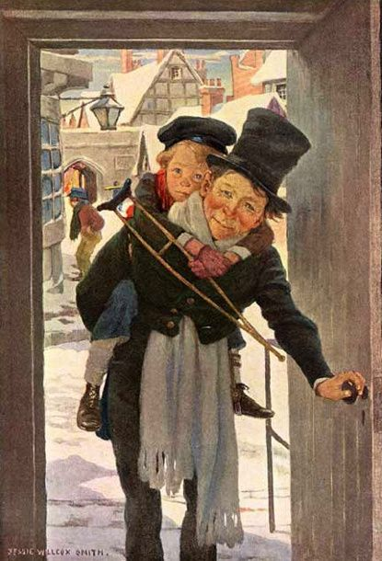

Figure 4.2: [Bob](https://en.wikipedia.org/wiki/Bob_Cratchit) (with son [Tim](https://en.wikipedia.org/wiki/Tiny_Tim_(A_Christmas_Carol))), working on website-copy.

As a first step, Alice runs git push just to make sure all her changes are on the remote repository:



[website (master)]$ git push

In real life, Alice would now need to add Bob as a collaborator on the website repository, which she could do at GitHub by clicking on **Settings > Collaborators** and then put Bob’s GitHub username in the Add collaborator box ([Figure 4.3](https://www.learnenough.com/git-tutorial?single_page=1#fig-github_add_collaborator)). Because we’re collaborating with ourselves, we can skip this step.

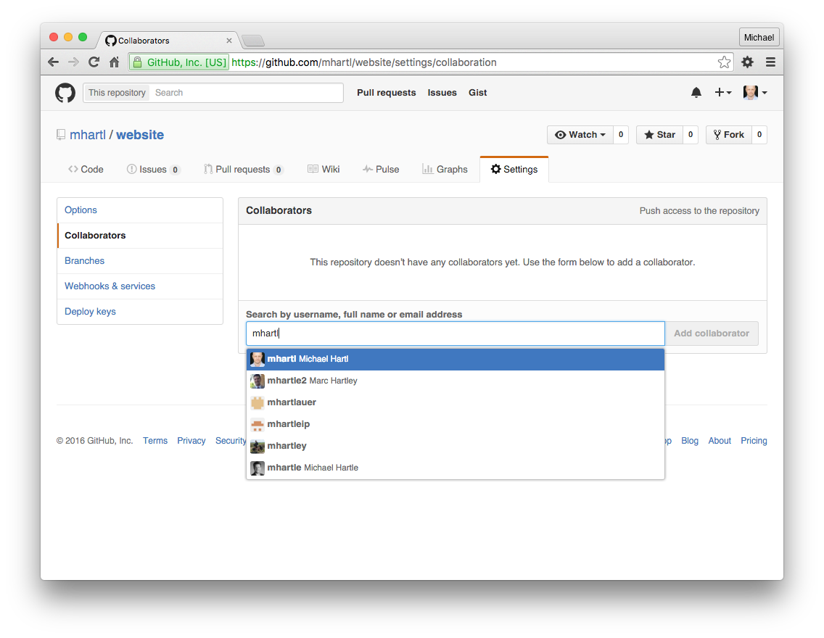

Figure 4.3: The GitHub page to add collaborators.

Once Bob gets the notification that he’s been added to the website repository, he can go to GitHub to get the *clone URL*, as shown in [Figure 4.4](https://www.learnenough.com/git-tutorial?single_page=1#fig-clone_url). This URL lets Bob make a full copy of the repository (including its history) using git clone.

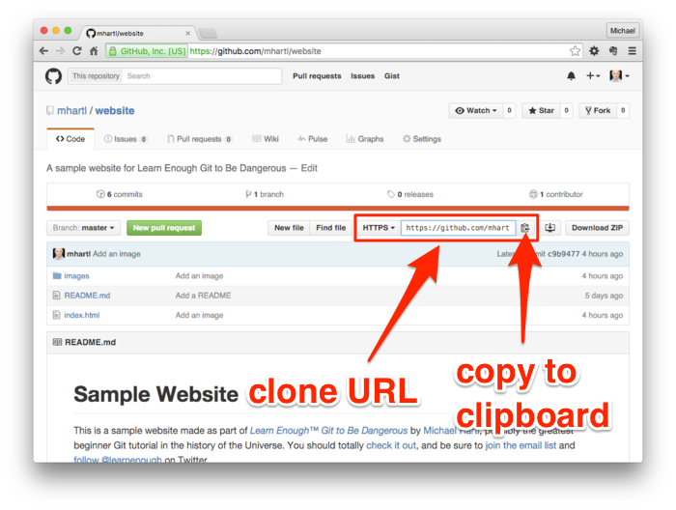

Figure 4.4: Finding the clone URL at GitHub.

Ordinarily, Bob would probably use his own repos directory, with a project called website as in Alice’s original, but because we’re only simulating the collaboration we’ll use the name website-copy for clarity. In addition, when doing something a little artificial like this I like to use a temp directory called ~/tmp,[3](https://www.learnenough.com/git-tutorial?single_page=1#cha-4_footnote-3) so create this directory if it doesn’t already exist on your system:

$ cd

$ mkdir tmp

Then cd to it and clone the repo to the local directory:



[~]$ cd tmp/

[tmp]$ git clone <clone URL> website-copy

Cloning into 'website-copy'...

[tmp]$ cd website-copy/

Here we’ve included the argument website-copy to git clone, thereby showing how to use a different name than the original repo, but usually you just run git clone <clone URL>, which uses the default repo name (in this case, website).

Now we’re ready to open the copy of the project and start making edits:



[website-copy (master)]$ atom .

For the purposes of this exercise, I recommend placing the editor windows for website and website-copy side by side, as shown in [Figure 4.5](https://www.learnenough.com/git-tutorial?single_page=1#fig-side_by_side).

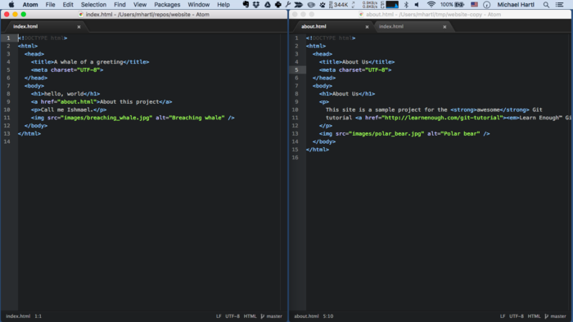

Figure 4.5: The website and website-copy editors running side by side.

To begin the collaboration, we’ll have Bob make a change to the site by wrapping the tutorial title on the About page in a link, like this:

<a href="https://www.learnenough.com/git-tutorial">…</a>

Here the ellipsis … represents the full title of the tutorial, *Learn Enough Git to Be Dangerous*. The resulting line is too long to display here, but we can wrap it, as shown in [Figure 4.6](https://www.learnenough.com/git-tutorial?single_page=1#fig-toggle_soft_wrap), with the result as shown in [Figure 4.7](https://www.learnenough.com/git-tutorial?single_page=1#fig-wrapped_about_page).

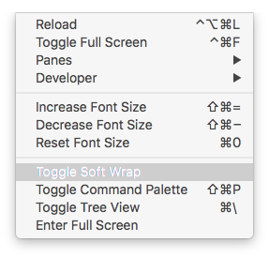

Figure 4.6: Toggling soft wrap in Atom.

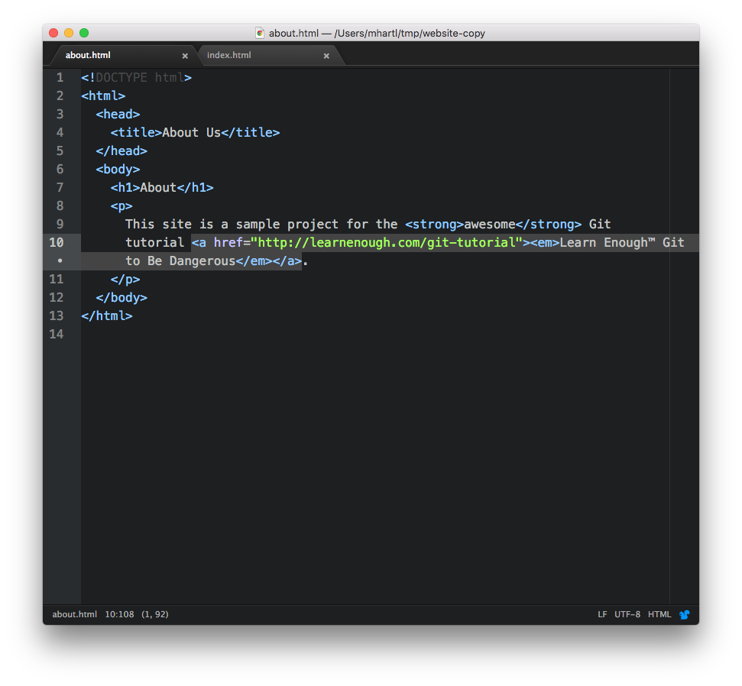

Figure 4.7: The About page with soft wrap activated.

If we look at the diff using git diff, we see the wrapped line ([Figure 4.8](https://www.learnenough.com/git-tutorial?single_page=1#fig-wrapped_diff)), which appears in a browser as shown in [Figure 4.9](https://www.learnenough.com/git-tutorial?single_page=1#fig-about_page_link).

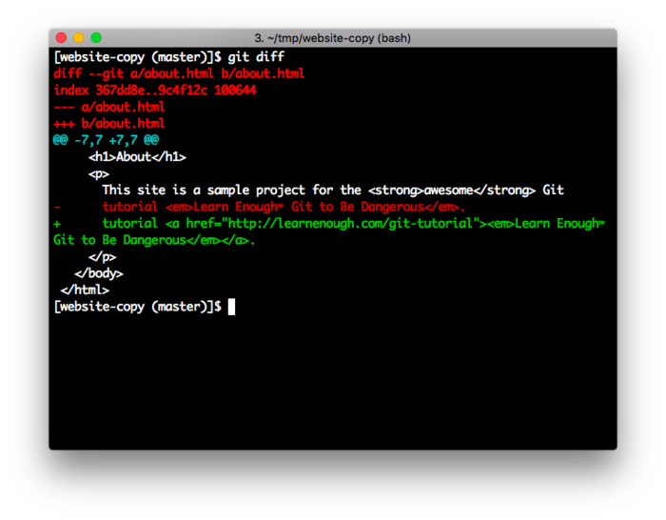

Figure 4.8: The diff with a wrapped line.

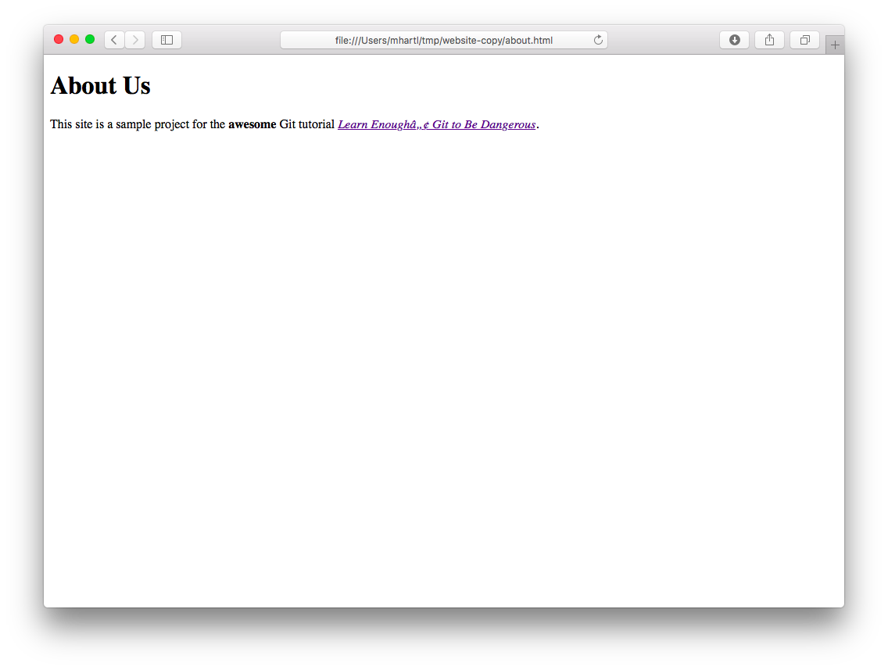

Figure 4.9: Linking the Git tutorial title on the About page.

Having added the link, Bob can commit his changes and push up to the remote repository:



[website-copy (master)]$ git commit -am "Add link to tutorial title"

[website-copy (master)]$ git push

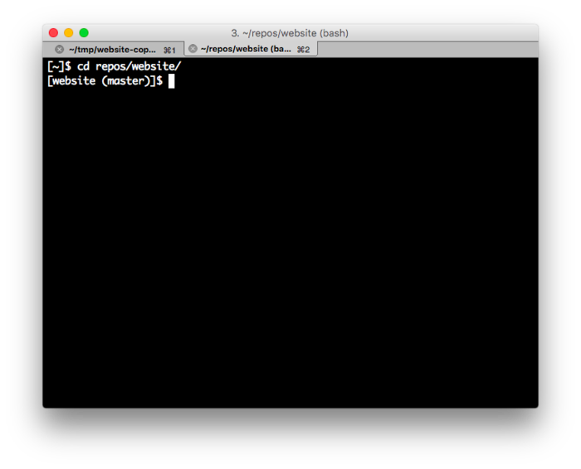

Figure 4.10: Using a new terminal tab for the original directory.

At this point, Bob might send Alice a notification that there’s a change ready, or Alice might just be diligent about checking for changes. In either case, Alice can get the changes from the remote origin by running git pull. I suggest opening up a new tab in your terminal window for Alice’s directory (as shown in [Figure 4.10](https://www.learnenough.com/git-tutorial?single_page=1#fig-new_tab)) and then pull as follows:



[website (master)]$ git pull

remote: Counting objects: 3, done.

remote: Compressing objects: 100% (1/1), done.

remote: Total 3 (delta 2), reused 3 (delta 2), pack-reused 0

Unpacking objects: 100% (3/3), done.

From https://github.com/mhartl/website

42db83e..986a487 master -> origin/master

Updating 42db83e..986a487

Fast-forward

about.html | 2 +-

1 file changed, 1 insertion(+), 1 deletion(-)

With that, Alice’s project should have Bob’s commit, and her copy of the About page should be identical to [Figure 4.9](https://www.learnenough.com/git-tutorial?single_page=1#fig-about_page_link). (Checking that Bob’s commit is present in the log is left as an exercise.)

[**4.1.1 Exercises**](https://www.learnenough.com/git-tutorial?single_page=1#sec-exercises_clone_push_pull)

1. As Alice, run git log to verify that the commit was pulled down correctly. Double-check the details using git log -p.
2. The whale picture added in [Listing 3.1](https://www.learnenough.com/git-tutorial?single_page=1#code-img_tag) ([Figure 3.1](https://www.learnenough.com/git-tutorial?single_page=1#fig-breaching_whale)) requires attribution under the [Creative Commons Attribution-NoDerivs 2.0 Generic](https://creativecommons.org/licenses/by-nd/2.0/) license. As Alice, link the image to the original attribution page, as shown in [Listing 4.1](https://www.learnenough.com/git-tutorial?single_page=1#code-whale_attribution). Commit the result and push to GitHub.
3. As Bob, pull in the changes from the previous exercise. Verify by refreshing the browser and by running git log -p that Bob’s repo has been properly updated.



Listing 4.1: Linking to the whale image’s attribution page. ~/repos/website/index.html

.

.

.

<a href="https://www.flickr.com/photos/28883788@N04/10097824543">

<img src="images/breaching_whale.jpg">

</a>

.

.

.

[**4.2 Pulling and merge conflicts**](https://www.learnenough.com/git-tutorial?single_page=1#sec-merge_conflicts)

In [Section 4.1](https://www.learnenough.com/git-tutorial?single_page=1#sec-clone_push_pull), Alice didn’t make any changes while Bob was making his commit, so there was no chance of conflict, but this is not always the case. In particular, when two collaborators edit the same file, it is possible that the changes might be irreconcilable. Git is pretty smart about merging in changes, and in general conflicts are surprisingly rare, but it’s important to be able to handle them when they occur. In this section, we’ll consider both cases in turn.

[**4.2.1 Non-conflicting changes**](https://www.learnenough.com/git-tutorial?single_page=1#sec-non_conflicting_changes)

We’ll start by having Alice and Bob make *non*-conflicting changes in the same file. Suppose Alice decides to change the top-level heading on the About page from “About” to “About Us”, as shown in [Listing 4.2](https://www.learnenough.com/git-tutorial?single_page=1#code-about_us_h1).



Listing 4.2: Alice’s change to the About page’s h1. ~/repos/website/about.html

<!DOCTYPE html>

<html>

.

.

.

<h1>About Us</h1>

.

.

.

</body>

</html>

After making this change, Alice commits and pushes as usual:



[website (master)]$ git commit -am "Change page heading"

[website (master)]$ git push



Figure 4.11: An image for Bob to add to the About page.

Meanwhile, Bob decides to add a new image ([Figure 4.11](https://www.learnenough.com/git-tutorial?single_page=1#fig-polar_bear))[4](https://www.learnenough.com/git-tutorial?single_page=1#cha-4_footnote-4) to the About page. He first downloads it with curl as follows:



[website-copy (master)]$ curl -o images/polar_bear.jpg \

> -OL cdn.learnenough.com/polar_bear.jpg

(Note here that you should type the backslash character \ in the first line, but you *shouldn’t* type the literal angle bracket > in the second line. The \ is used for a *line continuation*, and after hitting return the > will be added automatically by your shell program.) He then adds it to about.html using the img tag, as shown in [Listing 4.3](https://www.learnenough.com/git-tutorial?single_page=1#code-about_page_added_image), with the result shown in [Figure 4.12](https://www.learnenough.com/git-tutorial?single_page=1#fig-about_with_polar_bear).



Listing 4.3: Adding an image to the About page. ~/tmp/website-copy/about.html

<!DOCTYPE html>

<html>

.

.

.

<img src="images/polar_bear.jpg" alt="Polar bear">

</body>

</html>

Note that Bob has included an alt attribute in [Listing 4.3](https://www.learnenough.com/git-tutorial?single_page=1#code-about_page_added_image), which is a text alternative to the image. The alt attribute is actually required by the HTML5 standard, and including it is a good practice because it’s used by [web spiders](https://en.wikipedia.org/wiki/Web_crawler) and by screen readers for the visually impaired.

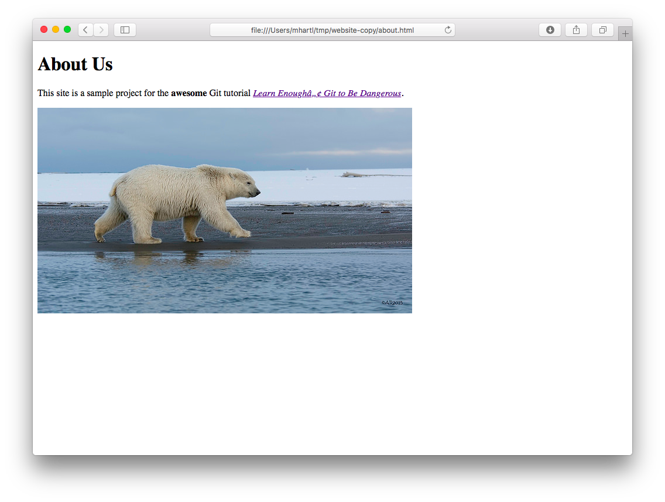

Figure 4.12: The About page with an added image.

Having made his change, Bob commits as usual:



[website-copy (master)]$ git add -A

[website-copy (master)]$ git commit -m "Add an image"

When he tries to push, though, something unexpected happens, as shown in [Listing 4.4](https://www.learnenough.com/git-tutorial?single_page=1#code-push_rejected).



Listing 4.4: Bob’s push, rejected.

[website-copy (master)]$ git push

To https://github.com/mhartl/website.git

! [rejected] master -> master (fetch first)

error: failed to push some refs to 'https://github.com/mhartl/website.git'

hint: Updates were rejected because the remote contains work that you do

hint: not have locally. This is usually caused by another repository pushing

hint: to the same ref. You may want to first integrate the remote changes

hint: (e.g., 'git pull ...') before pushing again.

hint: See the 'Note about fast-forwards' in 'git push --help' for details.

Because of the changes Alice already pushed, Git won’t let Bob’s push go through. As indicated by the highlighted line above, the solution to this is for Bob to pull:



[website-copy (master)]$ git pull

Even though Alice made changes to about.html, there is no conflict because Git figures out how to combine the diffs. In particular, git pull brings in the changes from the remote repo and uses merge to combine them automatically, adding the option to add a commit message by dropping Bob into the default editor, which on most systems is Vim ([Figure 4.13](https://www.learnenough.com/git-tutorial?single_page=1#fig-merge_editor)). (This is but one of many reasons why [*Learn Enough Text Editor to Be Dangerous*](https://www.learnenough.com/text-editor) covers [Minimum Viable Vim](https://www.learnenough.com/r/learn_enough_text_editor/vim/mvv#sec-mvv).) To get the merge to go through, you can simply quit out of Vim using :q.

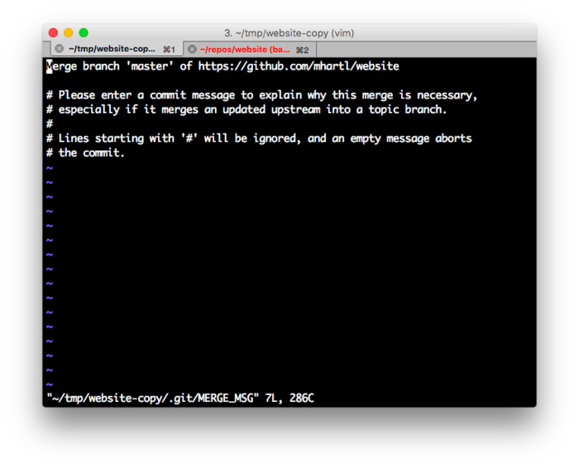

Figure 4.13: The default editor for merging from a git pull.

We can confirm that this worked by checking the log, which shows both the merge commit and Alice’s commit from the original copy ([Listing 4.5](https://www.learnenough.com/git-tutorial?single_page=1#code-git_log_merge)).



Listing 4.5: The Git log after Bob merges in Alice’s changes. (Exact results will differ.)

[website-copy (master)]$ git log

commit 86dccde63ac15331a068ce79fa9c83d8b784b28b

Merge: 9b7eda1 5ca69e4

Author: Michael Hartl <michael@michaelhartl.com>

Date: Mon Dec 28 13:14:44 2015 -0800

Merge branch 'master' of https://github.com/mhartl/website

commit 9b7eda1b0a95740a241684b82d4474aa8f16ae45

Author: Michael Hartl <michael@michaelhartl.com>

Date: Mon Dec 28 13:13:37 2015 -0800

Add an image

commit 5ca69e4dca9487b5cd7e1be52222c5389392527d

Author: Michael Hartl <michael@michaelhartl.com>

Date: Mon Dec 28 13:02:42 2015 -0800

Change page heading

If Bob now pushes, it should go through as expected:



$ git push

This puts Bob’s changes on the remote repo, which means Alice can pull them in:



$ git pull

Alice can confirm that her repo now includes Bob’s changes by inspecting the Git log, which should match the results you got in [Listing 4.5](https://www.learnenough.com/git-tutorial?single_page=1#code-git_log_merge). Meanwhile, she can refresh her browser to see Bob’s cool new [ursine](https://en.wiktionary.org/wiki/ursine#English) addition ([Figure 4.14](https://www.learnenough.com/git-tutorial?single_page=1#fig-about_polar_bear_alice)).

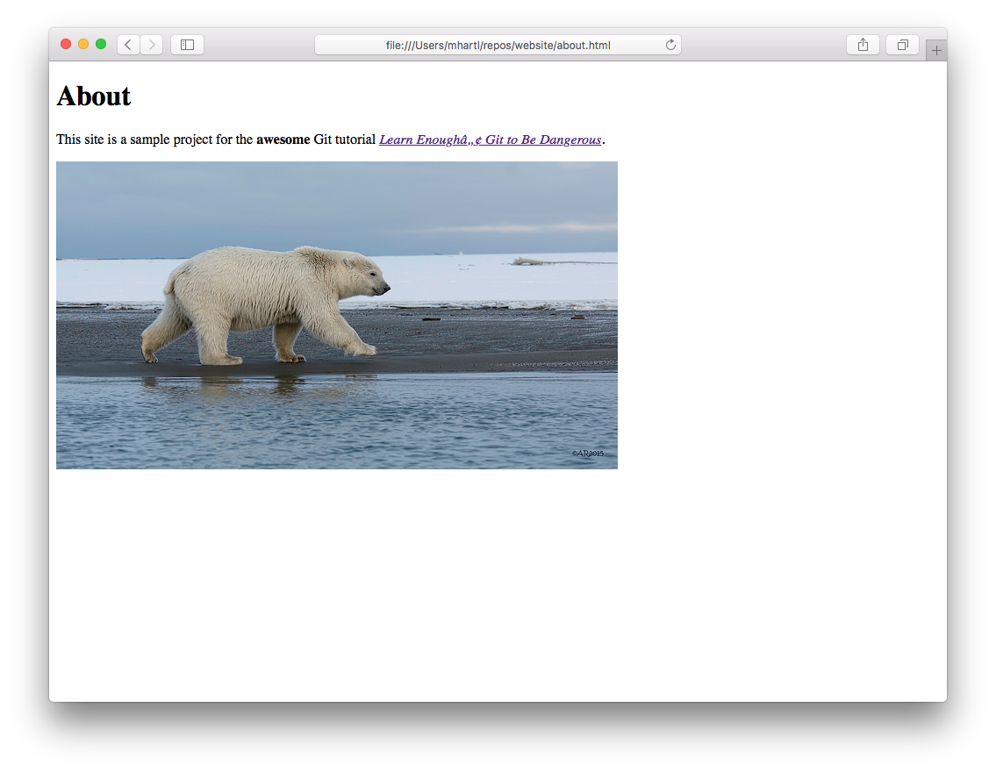

Figure 4.14: Confirming that Alice’s repo includes Bob’s added image.

[**4.2.2 Conflicting changes**](https://www.learnenough.com/git-tutorial?single_page=1#sec-conflicting_changes)

Even though Git’s merge algorithms can often figure out how to combine changes from different collaborators, sometimes there’s no avoiding a conflict. For example, suppose both Alice and Bob notice that the required alt attribute is missing from the image included in [Listing 3.1](https://www.learnenough.com/git-tutorial?single_page=1#code-img_tag) and decide to correct the issue by adding one.



Listing 4.6: Alice’s image alt. ~/repos/website/index.html

<!DOCTYPE html>

<html>

.

.

.

<a href="https://www.flickr.com/photos/28883788@N04/10097824543">

<img src="images/breaching_whale.jpg" alt="Breaching whale">

</a>

</body>

</html>

First, Alice adds the alt attribute “Breaching whale” ([Listing 4.6](https://www.learnenough.com/git-tutorial?single_page=1#code-breaching_whale_alt)) and then commits and pushes her change:[5](https://www.learnenough.com/git-tutorial?single_page=1#cha-4_footnote-5)



[website (master)]$ git commit -am "Add necessary image alt"

[website (master)]$ git push



Listing 4.7: Bob’s image alt. ~/tmp/website-copy/index.html

<!DOCTYPE html>

<html>

.

.

.

<a href="https://www.flickr.com/photos/28883788@N04/10097824543">

<img src="images/breaching_whale.jpg" alt="Whale">

</a>

</body>

</html>

Meanwhile, Bob adds his own alt attribute, “Whale” ([Listing 4.7](https://www.learnenough.com/git-tutorial?single_page=1#code-whale_alt)), and commits his change:



[website-copy (master)]$ git commit -am "Add an alt attribute"

If Bob tries to push, he’ll be met with the same rejection message shown in [Listing 4.4](https://www.learnenough.com/git-tutorial?single_page=1#code-push_rejected), which means he should pull—but that comes at a cost:



[website-copy (master)]$ git pull

remote: Counting objects: 3, done.

remote: Compressing objects: 100% (1/1), done.

remote: Total 3 (delta 2), reused 3 (delta 2), pack-reused 0

Unpacking objects: 100% (3/3), done.

From https://github.com/mhartl/website

5ca69e4..7ada3b5 master -> origin/master

Auto-merging index.html

CONFLICT (content): Merge conflict in index.html

Automatic merge failed; fix conflicts and then commit the result.

[website-copy (master|MERGING)]$

As indicated in the second highlighted line, Git has detected a merge conflict from Bob’s pull, and his working copy has been put into a special branch state called master|MERGING.

Bob can see the effect of this conflict by viewing index.html in his text editor, as shown in [Figure 4.15](https://www.learnenough.com/git-tutorial?single_page=1#fig-merge_conflict). Supposing Bob prefers Alice’s more descriptive alt text, he can resolve the conflict by deleting all but the line with alt="Breaching whale", as seen in [Figure 4.16](https://www.learnenough.com/git-tutorial?single_page=1#fig-edited_merge_conflict).

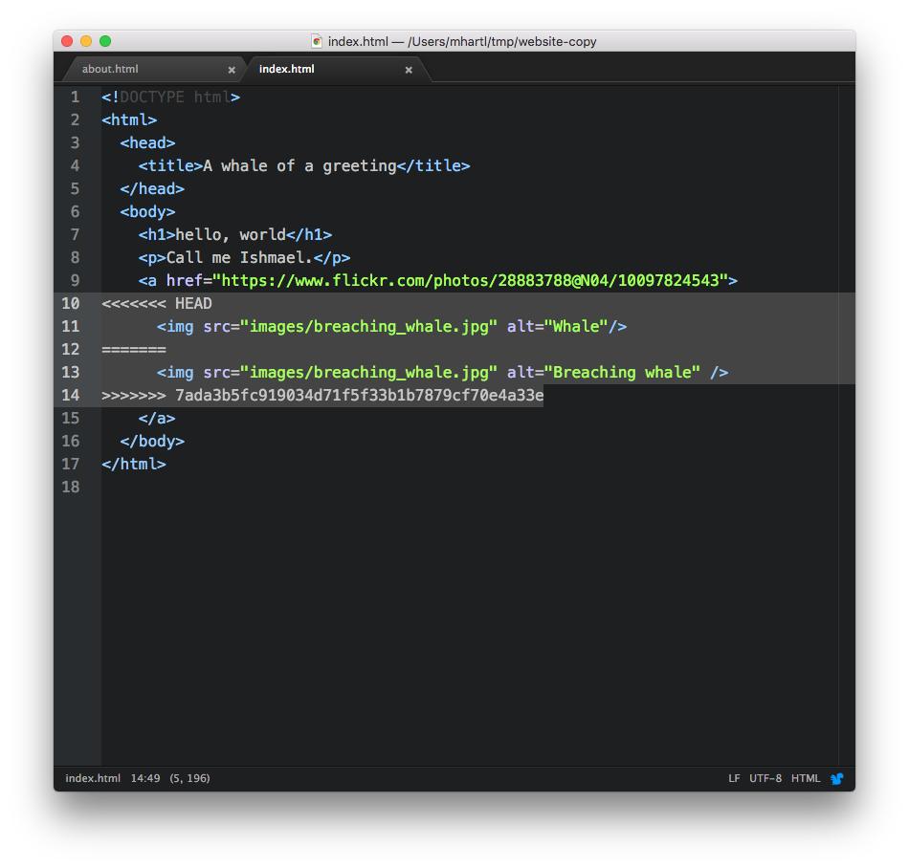

Figure 4.15: A file with a merge conflict.

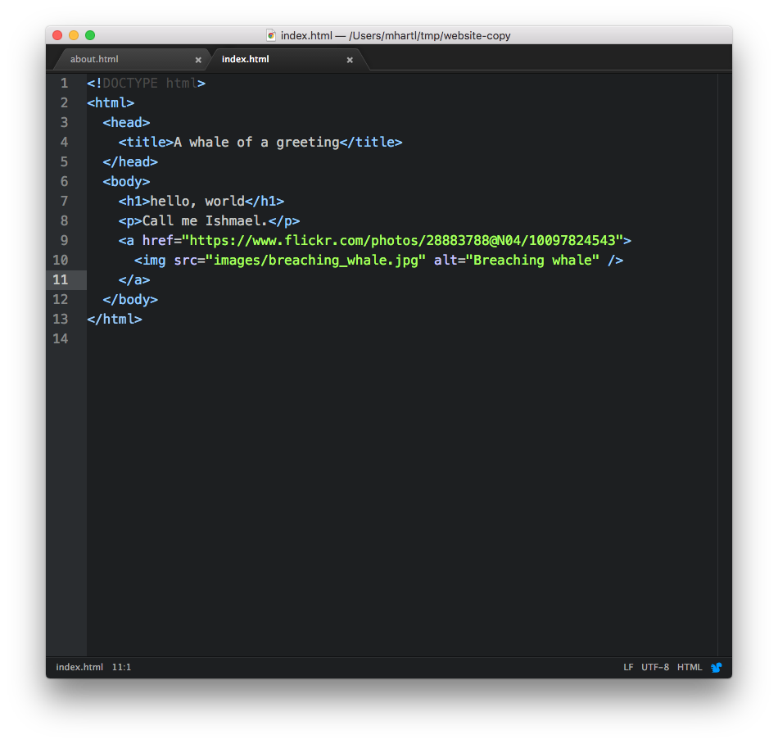

Figure 4.16: The HTML file edited to remove the merge conflict.

After saving the file, Bob can commit his change, which causes the prompt to revert back to displaying the master branch, and at that point he’s ready to push:



[website-copy (master|MERGING)]$ git commit -am "Use longer alt attribute"

[website-copy (master)]$ git push

Alice’s and Bob’s repos now have the same content, but it’s still a good idea for Alice to pull in Bob’s merge commit:



[website (master)]$ git pull

Because of the potential for conflict, it’s a good idea to do a git pull before making any changes on a project with multiple collaborators. Even then, on a long enough timeline some conflicts are inevitable, and with the techniques in this section you’re now in a position to handle them.

[**4.2.3 Exercises**](https://www.learnenough.com/git-tutorial?single_page=1#sec-exercises_merge_conflicts)

1. Change your default Git editor from Vim to Atom. *Hint*: [Google for it](http://lmgtfy.com/?q=git+change+default+editor+atom). (This is an absolutely *classic* application of technical sophistication ([Box 1.2](https://www.learnenough.com/git-tutorial?single_page=1#aside-technical_sophistication)): With a well-chosen Google search, you can often go from “I have no idea how to do this” to “It’s done” in under 30 seconds.)
2. The polar bear picture added in [Listing 4.3](https://www.learnenough.com/git-tutorial?single_page=1#code-about_page_added_image) ([Figure 4.11](https://www.learnenough.com/git-tutorial?single_page=1#fig-polar_bear)) requires attribution under the [Creative Commons Attribution 2.0 Generic](https://creativecommons.org/licenses/by/2.0/) license. As Alice, link the image to the original attribution page, as shown in [Listing 4.8](https://www.learnenough.com/git-tutorial?single_page=1#code-polar_bear_attribution). Then run git commit -a *without* including -m and a command-line message. This should drop you into the default Git editor. Quit the editor *without* including a message, which cancels the commit.
3. Run git commit -a again, but this time add the commit message “Add polar bear attribution link”. Then hit return a couple of times and add a longer message of your choice. (One example appears in [Figure 4.17](https://www.learnenough.com/git-tutorial?single_page=1#fig-longer_message).) Save the message and exit the editor.
4. Run git log to confirm that both the short and longer messages correctly appear. After pushing the changes to GitHub, navigate to the page for the commit to confirm that both the short and longer messages correctly appear.
5. As Bob, pull in the changes to the About page. Verify by refreshing the browser and by running git log -p that Bob’s repo has been properly updated.



Listing 4.8: Linking to the polar bear image’s attribution page. ~/repos/website/about.html

.

.

.

<a href="https://www.flickr.com/photos/puliarfanita/22959238329">

<img src="images/polar_bear.jpg" alt="Polar bear">

</a>

.

.

.

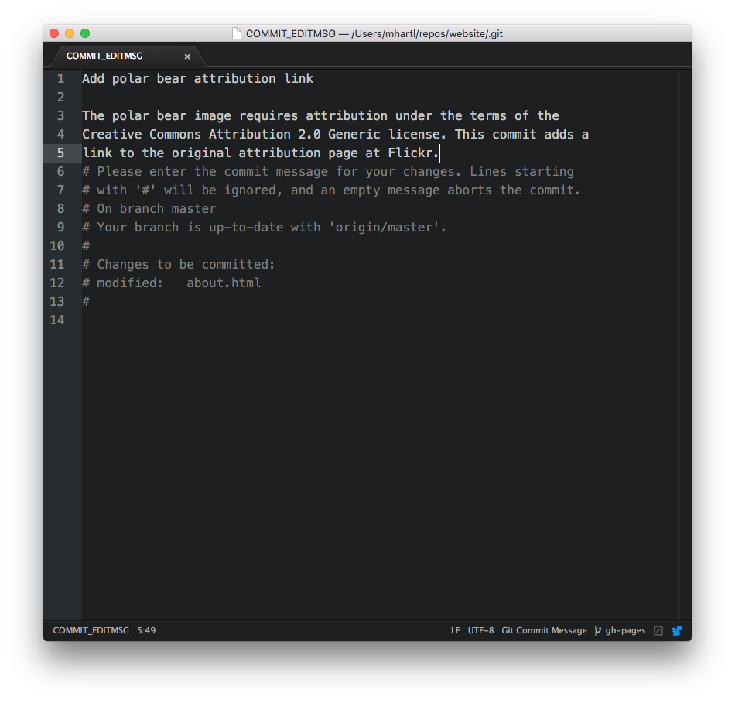

Figure 4.17: Adding a longer message in a text editor.

[**4.3 Pushing branches**](https://www.learnenough.com/git-tutorial?single_page=1#sec-pushing_branches)

In this section, we’ll apply our newfound collaboration skills to get Alice to request a bugfix from Bob, who will make the correction and then share the result with Alice. In the process, we’ll learn how to collaborate on branches other than master, thereby applying the material from [Section 3.3](https://www.learnenough.com/git-tutorial?single_page=1#sec-branching_and_merging) as well.

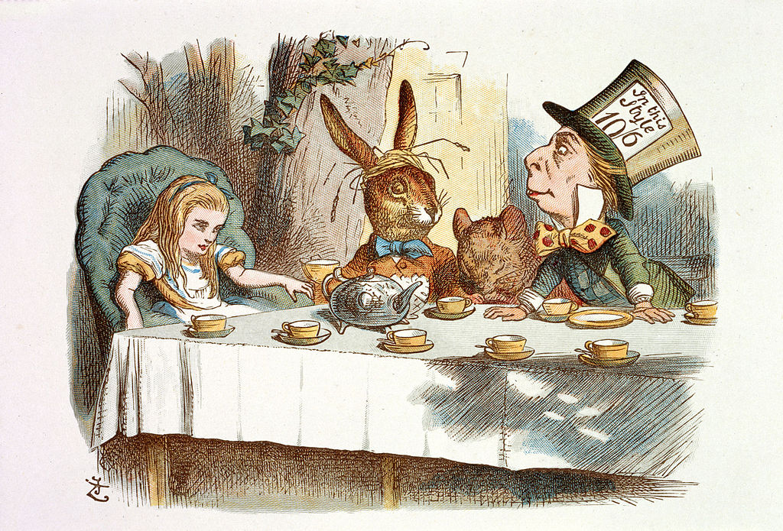

Figure 4.18: Alice has a [tea party](https://www.alice-in-wonderland.net/resources/chapters-script/alices-adventures-in-wonderland/chapter-7/) to attend and so asks Bob to fix the website.

Recall from [Section 3.3](https://www.learnenough.com/git-tutorial?single_page=1#sec-branching_and_merging) that the trademark character ™ is currently broken on the About page ([Figure 3.7](https://www.learnenough.com/git-tutorial?single_page=1#fig-about_page_broken)). Alice suspects the fix for this involves adding some markup to the HTML template for the website’s pages, but she’s already agreed to attend a tea party ([Figure 4.18](https://www.learnenough.com/git-tutorial?single_page=1#fig-tea_party)),[6](https://www.learnenough.com/git-tutorial?single_page=1#cha-4_footnote-6) so she only has time to add a couple of *HTML comments* requesting for Bob to add the relevant fix, as shown in [Listing 4.9](https://www.learnenough.com/git-tutorial?single_page=1#code-about_stub) and [Listing 4.10](https://www.learnenough.com/git-tutorial?single_page=1#code-index_stub). (We’ll cover HTML comments further in [*Learn Enough HTML to Be Dangerous*](https://www.learnenough.com/html).)



Listing 4.9: A stub for the fix to the ™ problem. ~/repos/website/about.html

<!DOCTYPE html>

<html>

<head>

<title>About Us</title>

<!-- Add something here to fix trademark -->

</head>

.

.

.

</html>

Listing 4.10: A stub to add the ™ fix to the index page. ~/repos/website/index.html

<!DOCTYPE html>

<html>

<head>

<title>A whale of a greeting</title>

<!-- Add something here to fix trademark -->

</head>

.

.

.

</html>

Notice that Alice has wisely asked Bob to fix the index page as well ([Listing 4.10](https://www.learnenough.com/git-tutorial?single_page=1#code-index_stub)) even though the current error only occurs on the About page. This way, any ™ or similar characters added to index.html will automatically work in the future. (As noted in [Section 3.3](https://www.learnenough.com/git-tutorial?single_page=1#sec-branching_and_merging), having to make such changes in multiple places is annoying, and it’s also brittle and error-prone. The correct solution is to use *templates*, which we’ll cover starting in [*Learn Enough CSS & Layout to Be Dangerous*](https://www.learnenough.com/css-and-layout).)

Alice has decided to follow a common convention and use a separate branch for the bugfix, which in this case she calls fix-trademark:



[website (master)]$ git checkout -b fix-trademark

[website (fix-trademark)]$

This shows something important: it’s possible to make changes to the working directory (in this case, the additions from [Listing 4.9](https://www.learnenough.com/git-tutorial?single_page=1#code-about_stub) and [Listing 4.10](https://www.learnenough.com/git-tutorial?single_page=1#code-index_stub)) *before* creating a new branch, as long as those changes haven’t yet been committed.

Having made the new branch for the fix, Alice can make a commit and push up the branch using git push:



[website (fix-trademark)]$ git commit -am "Add placeholders for the TM fix"

[website (fix-trademark)]$ git push -u origin fix-trademark

Here Alice has used exactly the same push syntax used in [Listing 2.1](https://www.learnenough.com/git-tutorial?single_page=1#code-github_push_template) to push the repo up to GitHub in the first place, with fix-trademark in place of master.

If Alice sends Bob a note before she heads off to her tea party, Bob will know to do a git pull to pull in Alice’s changes:



[website-copy (master)]$ git pull

remote: Counting objects: 4, done.

remote: Compressing objects: 100% (1/1), done.

remote: Total 4 (delta 3), reused 4 (delta 3), pack-reused 0

Unpacking objects: 100% (4/4), done.

From https://github.com/mhartl/website

* [new branch] fix-trademark -> origin/fix-trademark

Already up-to-date.

Bob can check his local working directory for the fix-trademark branch that Alice created and pushed, but it isn’t there:



[website-copy (master)]$ git branch

* master

The reason is that the branch is associated with the remote origin, and such branches aren’t displayed by default. To see it, Bob can use the -a option (for “all”):[7](https://www.learnenough.com/git-tutorial?single_page=1#cha-4_footnote-7)



[website-copy (master)]$ git branch -a

* master

remotes/origin/HEAD -> origin/master

remotes/origin/fix-trademark

remotes/origin/master

To start work on fix-trademark on his local copy, Bob just needs to check it out. By using the same name (i.e., fix-trademark), he arranges for it to be associated with the upstream branch on GitHub, which means that git push will automatically push up his changes:



[website-copy (master)]$ git checkout fix-trademark

Branch fix-trademark set up to track remote branch fix-trademark from origin.

Switched to a new branch 'fix-trademark'

[website-copy (fix-trademark)]$

At this point, Bob can diff against master to see what he’s dealing with:

[website-copy (fix-trademark)]$ git diff master

diff --git a/about.html b/about.html

index 8a879f5..3d567eb 100644

--- a/about.html

+++ b/about.html

@@ -2,6 +2,7 @@

<html>

<head>

<title>About Us</title>

+ <!-- Add something here to fix trademark display -->

</head>

<body>

<h1>About Us</h1>

diff --git a/index.html b/index.html

index fcb80f4..c4920c0 100644

--- a/index.html

+++ b/index.html

@@ -2,6 +2,7 @@

<html>

<head>

<title>A whale of a greeting</title>

+ <!-- Add something here to fix trademark display -->

</head>

<body>

<h1>hello, world</h1>

Now all Bob has to do is actually implement the fix. If you’d like a challenging exercise in technical sophistication, try Googling around to see if you can figure out what the problem might be, and also how you might fix it. In case you’d like to do this, I’ll wait here while you look…

All right, the problem is that the page doesn’t have the right *character encoding* to display non-[ASCII](https://en.wikipedia.org/wiki/ASCII) characters like ™, ®, or £. The fix involves using a tag called meta to tell browsers to use a character set (or charset for short) called [UTF-8](https://en.wikipedia.org/wiki/UTF-8), which will let our page display anything that’s part of the enormous set of [Unicode](https://en.wikipedia.org/wiki/Unicode) characters. The result, which you would not necessarily be able to guess, appears in [Listing 4.11](https://www.learnenough.com/git-tutorial?single_page=1#code-about_meta) and [Listing 4.12](https://www.learnenough.com/git-tutorial?single_page=1#code-index_meta).



Listing 4.11: A fix for the ™ problem. ~/tmp/website-copy/about.html

<!DOCTYPE html>

<html>

<head>

<title>About Us</title>

<meta charset="utf-8">

</head>

.

.

.

</html>

Listing 4.12: Adding the ™ fix to the index page. ~/tmp/website-copy/index.html

<!DOCTYPE html>

<html>

<head>

<title>A whale of a greeting</title>

<meta charset="utf-8">

</head>

.

.

.

</html>

Like the img tag introduced in [Section 3.1](https://www.learnenough.com/git-tutorial?single_page=1#sec-commit_push_repeat), meta is a void element (self-closing) and so has no closing tag.

Having made the change, Bob can confirm the fix by reloading the page in his browser, as shown in [Figure 4.19](https://www.learnenough.com/git-tutorial?single_page=1#fig-working_trademark).

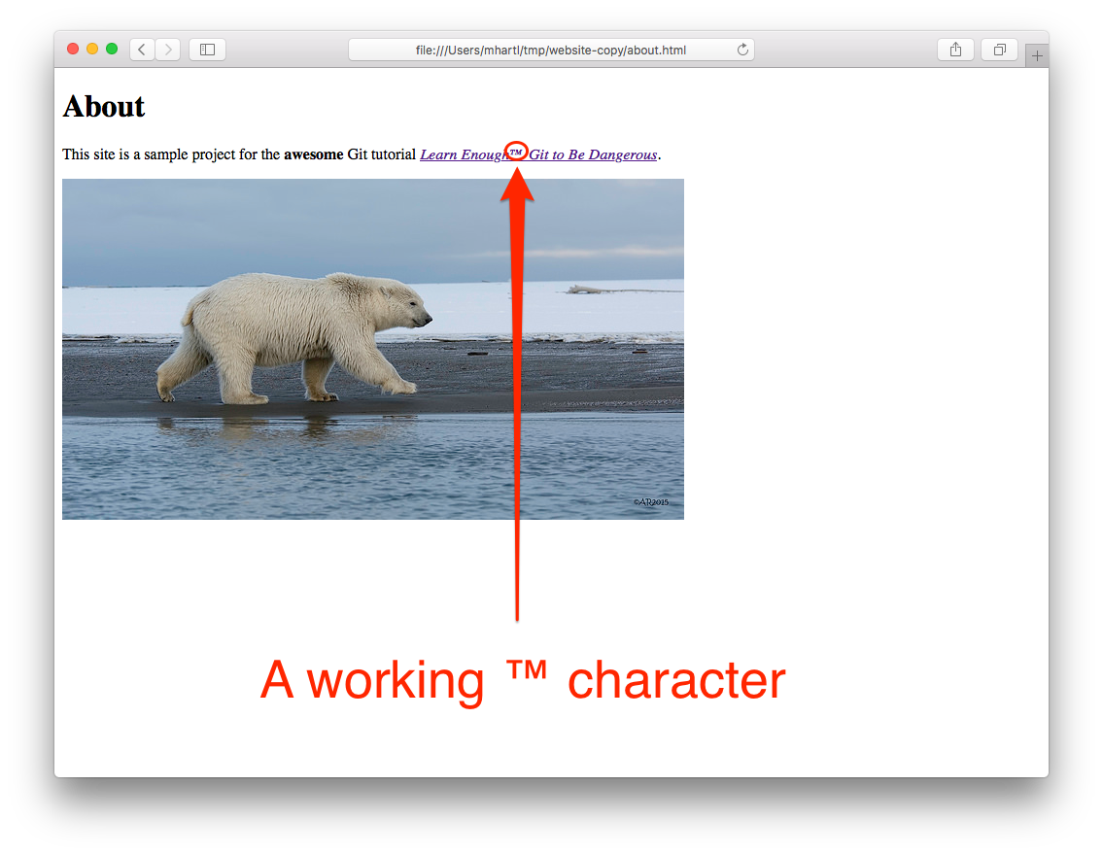

Figure 4.19: Confirming a working trademark character.

Confident that his solution is correct, Bob can now make a commit and push the fix up to the remote server:



[website-copy (fix-trademark)]$ git commit -am "Fix trademark character display"

[website-copy (fix-trademark)]$ git push

With that, Bob sends a note to Alice that the fix is pushed, and heads out for some well-deserved rest ([Figure 4.20](https://www.learnenough.com/git-tutorial?single_page=1#fig-beach_relaxing)).[8](https://www.learnenough.com/git-tutorial?single_page=1#cha-4_footnote-8)



Figure 4.20: Bob’s reward for a job well-done.

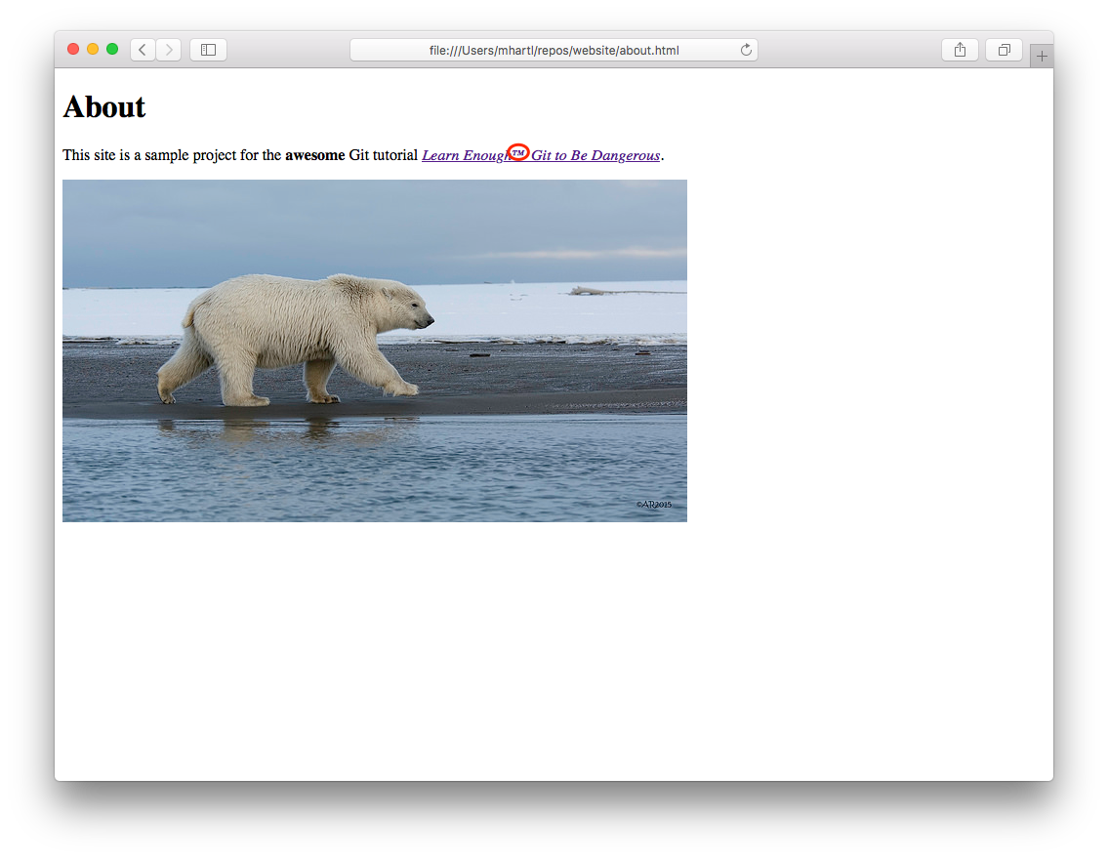

Figure 4.21: Reconfirming the trademark fix before merging.

Alice, now back from her tea party, gets Bob’s note and pulls in his fix:



[website (fix-trademark)]$ git pull

She refreshes her browser to confirm that the ™ character displays properly on her end of things ([Figure 4.21](https://www.learnenough.com/git-tutorial?single_page=1#fig-working_trademark_confirmed)), and then merges the changes into master:



[website (fix-trademark)]$ git checkout master

[website (master)]$ git merge fix-trademark

[website (master)]$ git push

With the final git push, Alice arranges for the remote master branch on GitHub to get the fix. (Syncing up Bob’s master branch is left as an exercise ([Section 4.3.1](https://www.learnenough.com/git-tutorial?single_page=1#sec-exercises_pushing_branches)).)

Of course, git push publishes the change only to a remote Git repository. Wouldn’t it be nice if there were a way to confirm that the ™ character—and the rest of the website—displays correctly on the live Web?

[**4.3.1 Exercises**](https://www.learnenough.com/git-tutorial?single_page=1#sec-exercises_pushing_branches)

1. Bob’s master branch doesn’t currently have Alice’s merge, so check out master as Bob and do a git pull. Confirm using git log that Alice’s merge commit is now present.
2. Delete the fix-trademark branch locally. Do you need to use the -D option ([Section 3.3.2](https://www.learnenough.com/git-tutorial?single_page=1#sec-exercises_branching_and_merging)), or is -d sufficient?
3. Delete the remote fix-trademark branch on GitHub. *Hint*: If you get stuck, [Google for it](http://lmgtfy.com/?q=git+delete+remote+branch).

[**4.4 A surprise bonus**](https://www.learnenough.com/git-tutorial?single_page=1#sec-a_surprise_bonus)

As hinted at the end of the last section, it would be nice to be able to confirm that the new character encoding works on a live web page. But this requires knowing how to deploy a live site to the Web, and that’s beyond the scope of a humble Git tutorial, right? Amazingly, the answer is no. The reason is that GitHub offers a free service called *GitHub Pages*, and *any* repository at GitHub containing static HTML is automatically available as a live website.

There is one minor prerequisite to using GitHub Pages, which is that you have to [verify your email address](https://help.github.com/articles/verifying-your-email-address) with GitHub. Once you’ve done that, though, all you need to do is configure your repository to use GitHub Pages on the master branch, which you can do by going to the settings ([Figure 4.22](https://www.learnenough.com/git-tutorial?single_page=1#fig-github_settings)) and then selecting the master and saving the changes ([Figure 4.23](https://www.learnenough.com/git-tutorial?single_page=1#fig-github_pages_master_branch)).

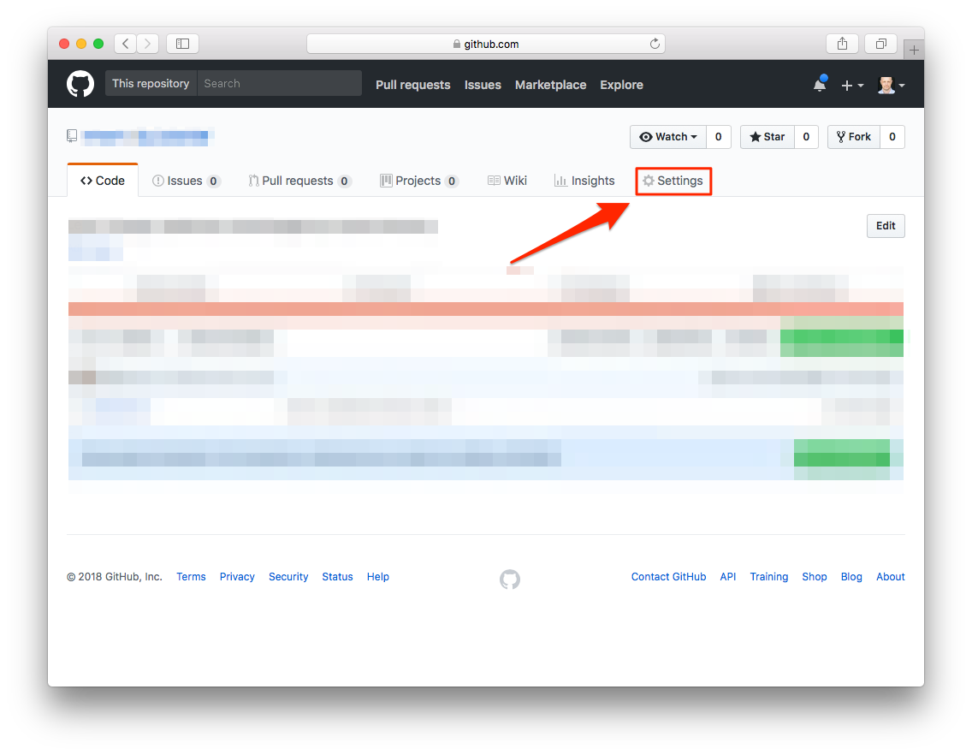

Figure 4.22: The settings for a GitHub repository.

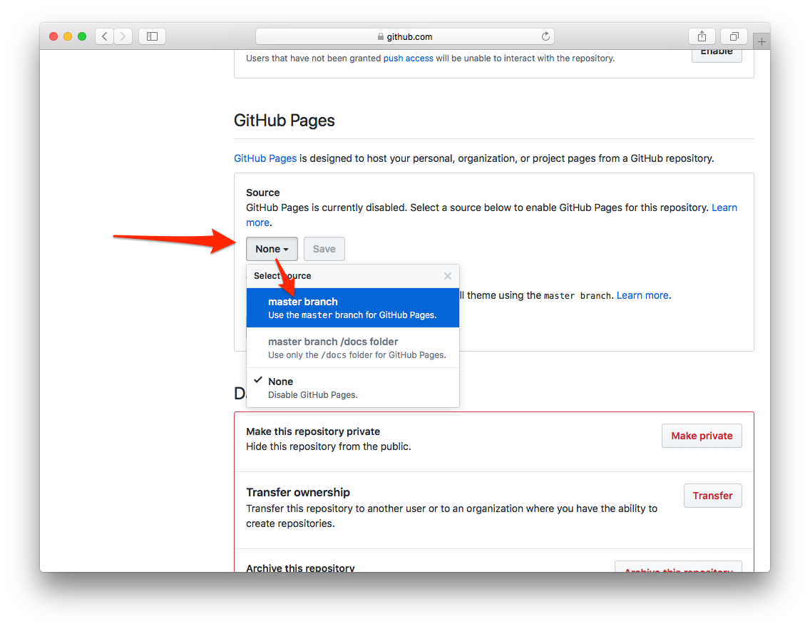

Figure 4.23: Serving our website from the master branch.

That’s it! Our website is now available at the URL

http://<name>.github.io/website/

where <name> is your GitHub username. Since my username is mhartl, my copy of the this tutorial’s website is at [mhartl.github.io/website/](http://mhartl.github.io/website), as shown in [Figure 4.24](https://www.learnenough.com/git-tutorial?single_page=1#fig-production_website).

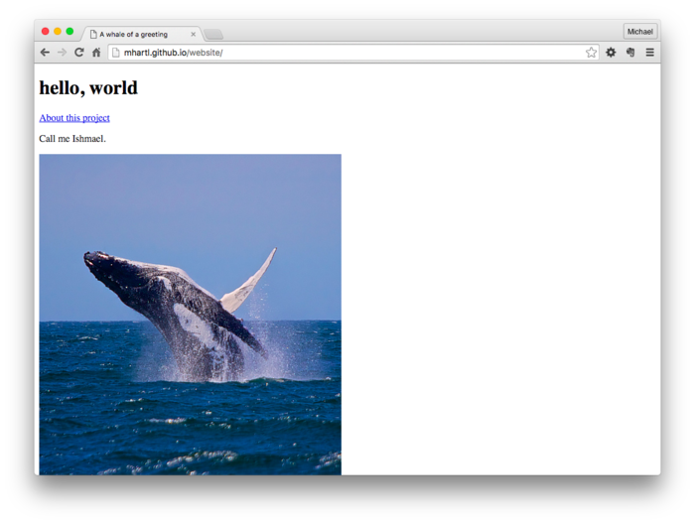

Figure 4.24: A production website at GitHub Pages.

Note that the URL http://<name>.github.io/website/ automatically displays index.html, which is the usual convention on the web: the index page is understood to be the default, so there’s no need to type it in. This is not the case with other pages, though, and if you follow the link to the About page you’ll see that the filename appears in the address bar ([Figure 4.25](https://www.learnenough.com/git-tutorial?single_page=1#fig-production_about_page)). You’ll also see in [Figure 4.25](https://www.learnenough.com/git-tutorial?single_page=1#fig-production_about_page) that the trademark character ™ renders correctly on a live website, just as we hoped it would.

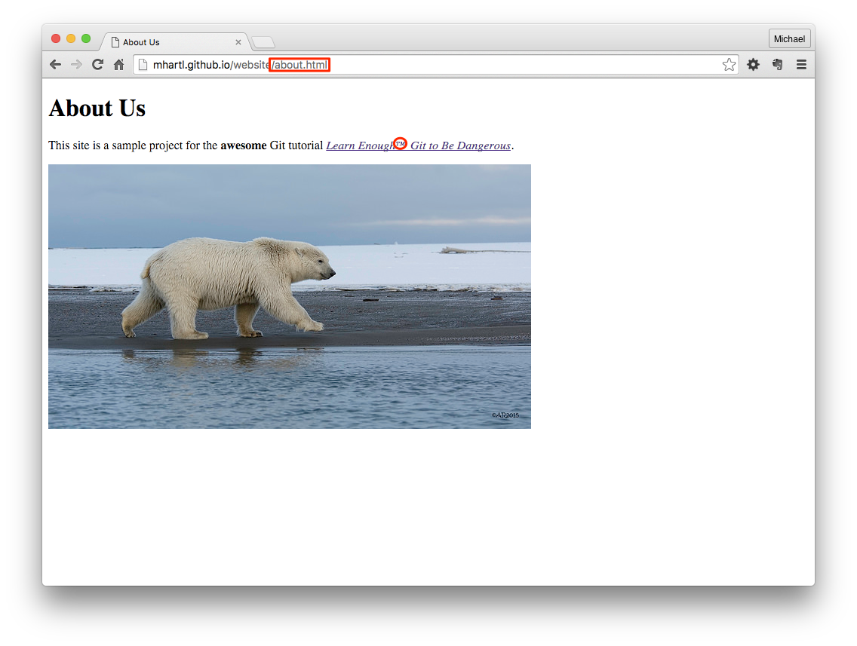

Figure 4.25: The About page in production.

Because static HTML pages by definition don’t change from one page view to the next, GitHub can [*cache*](https://en.wikipedia.org/wiki/Web_cache) them efficiently, which makes GitHub Pages sites both fast and cheap to serve (which is why GitHub can afford to offer them for free). This means that such sites can handle a potentially huge amount of traffic, making Pages suitable for production websites. The example website in this tutorial is really just a toy, but it’s a great start, and we’ll build on this foundation to make a nearly industrial-grade website in [*Learn Enough HTML to Be Dangerous*](https://www.learnenough.com/html) and a fully industrial-grade site in [*Learn Enough CSS & Layout to Be Dangerous*](https://www.learnenough.com/css-and-layout).

[**4.4.1 Exercises**](https://www.learnenough.com/git-tutorial?single_page=1#sec-exercises_surprise_bonus)

1. On the About page, add a link back to index.html. Commit and push your change and verify that the link works on the production site.
2. As [covered](https://www.learnenough.com/r/learn_enough_command_line/manipulating_files/renaming_copying_deleting#sec-renaming_copying_deleting) in [*Learn Enough Command Line to Be Dangerous*](https://www.learnenough.com/command-line), two of the most important Unix commands are mv and rm. Git provides analogues of these commands, which have the same effect on local files while also arranging to track the changes. Experiment with these commands via the following sequence: Create a file with some [*lorem ipsum*](http://lipsum.com/) text, add & commit it, rename it with git mv & commit, then remove it with git rm and commit again. Examine the results of git log -p to see how Git handled the operations.
3. To practice the process of making a new Git repository, make a second project called second_website in the repos directory. Create an index.html file with the content “hello, again!” and follow the steps (starting in [Section 1.2](https://www.learnenough.com/git-tutorial?single_page=1#sec-initializing_the_repo)) needed to deploy it to the live Web.
4. Make a third, secret project called secret_project. Touch files called foo, bar, and baz in the main project directory, and then follow the steps to initialize the repository and commit the initial results. Then, instead of pushing to a public repository at GitHub, create a free *private* repository at [Bitbucket](http://bitbucket.org/). (You may have to [sign up for a Bitbucket account](https://bitbucket.org/account/signup/) and [share the SSH keys](http://lmgtfy.com/?q=bitbucket+ssh+keys) you created in [Section 2.1](https://www.learnenough.com/git-tutorial?single_page=1#sec-github).) The result will be a repository suitable for securely sharing with private collaborators.

[**4.5 Summary**](https://www.learnenough.com/git-tutorial?single_page=1#sec-summary_collaborating)

Important commands from this section are summarized in [Table 4.1](https://www.learnenough.com/git-tutorial?single_page=1#table-collaborating).

|  |  |  |
| --- | --- | --- |
| **Command** | **Description** | **Example** |
| git clone <URL> | Copy repo (incl. full history) to local disk | $ git clone https://ex.co/repo.git |
| git pull | Pull in changes from remote repository | $ git pull |
| git branch -a | List all branches | $ git branch -a |
| git checkout <br> | Check out remote branch and configure for push | $ git checkout fix-trademark |

Table 4.1: Important commands from [Chapter 4](https://www.learnenough.com/git-tutorial?single_page=1#cha-collaborating).

[**4.6 Advanced setup**](https://www.learnenough.com/git-tutorial?single_page=1#sec-advanced_setup)

This section contains some optional advanced Git setup. The main features are adding an alias for checking out branches, adding the branch name to the Unix prompt, and enabling branch name tab completion. Following the steps in this section should be within your capabilities if you completed [*Learn Enough Command Line to Be Dangerous*](https://www.learnenough.com/command-line) and [*Learn Enough Text Editor to Be Dangerous*](https://www.learnenough.com/text-editor), but they can be tricky, so use your technical sophistication ([Box 1.2](https://www.learnenough.com/git-tutorial?single_page=1#aside-technical_sophistication)) if you get stuck.

[**4.6.1 A checkout alias**](https://www.learnenough.com/git-tutorial?single_page=1#sec-a_checkout_alias)

In [Chapter 1](https://www.learnenough.com/git-tutorial?single_page=1#cha-getting_started), we added global configuration settings for the name and email address ([Listing 1.1](https://www.learnenough.com/git-tutorial?single_page=1#code-global_config)) to be included automatically when making commits. Now we’ll add a third config setting, an *alias* to make it easier to check out branches.

Throughout this tutorial, we’ve used git checkout to check out branches (e.g., [Listing 3.3](https://www.learnenough.com/git-tutorial?single_page=1#code-checkout_about_page)), but most experienced Git users configure their systems to use the shorter command git co.[9](https://www.learnenough.com/git-tutorial?single_page=1#cha-4_footnote-9) The way to do this is with a Git *alias*: much as the Bash aliases [covered](https://www.learnenough.com/r/learn_enough_text_editor/vim/saving_and_quitting_files#sec-saving_and_quitting_files) in [*Learn Enough Text Editor to Be Dangerous*](https://www.learnenough.com/text-editor) let us add commands to our Bash shell, Git aliases let us add commands to our Git system. In particular, the way to add the co alias is to run the command shown in [Listing 4.13](https://www.learnenough.com/git-tutorial?single_page=1#code-git_co).

Listing 4.13: Adding an alias for git co.

$ git config --global alias.co checkout

In effect, this adds co as a new Git command, and running [Listing 4.13](https://www.learnenough.com/git-tutorial?single_page=1#code-git_co) allows us to replace checkout in commands like

$ git checkout master

with the more compact co command, as follows:

$ git co master

For maximum compatibility with systems that don’t have co configured, this tutorial has always used the full checkout command, but in real life I nearly always use git co.

[**4.6.2 Prompt branches and tab completion**](https://www.learnenough.com/git-tutorial?single_page=1#sec-prompt_branches_and_tab_completion)

In this section, we’ll add two final advanced customizations. First, we’ll arrange for the command-line prompt to include the name of the current branch. Second, we’ll add the ability to fill in Git branch names using [*tab completion*](https://www.learnenough.com/r/learn_enough_command_line/manipulating_files/renaming_copying_deleting#aside-tab_completion), which is especially convenient when dealing with longer branch names. Both of these features come as shell scripts with the Git source code distribution, which can be downloaded as shown in [Listing 4.14](https://www.learnenough.com/git-tutorial?single_page=1#code-git_shell_scripts).

Listing 4.14: Downloading scripts for branch display and tab completion.

$ curl -o ~/.git-prompt.sh -OL cdn.learnenough.com/git-prompt.sh

$ curl -o ~/.git-completion.bash -OL cdn.learnenough.com/git-completion.bash

Here the -o flag arranges to save the files locally under slightly different names from the ones on the server, prepending a dot . so that the files are [hidden](https://www.learnenough.com/r/learn_enough_command_line/manipulating_files/listing#sec-hidden_files) and saving them in the home directory ~.

After downloading the scripts as in [Listing 4.14](https://www.learnenough.com/git-tutorial?single_page=1#code-git_shell_scripts), on some systems we need to make them executable, which we can do with the chmod command ([mentioned before](https://www.learnenough.com/r/learn_enough_text_editor/advanced_text_editing/writing_an_executable_script#sec-writing_an_executable_script) in [*Learn Enough Text Editor to Be Dangerous*](https://www.learnenough.com/text-editor)):

$ chmod +x ~/.git-prompt.sh

$ chmod +x ~/.git-completion.bash

Next, we need to tell the shell about the new commands, so open up the Bash profile file in your favorite editor (which for simplicity I’ll assume is Atom):

$ atom ~/.bash_profile

Then add the configuration shown in [Listing 4.15](https://www.learnenough.com/git-tutorial?single_page=1#code-git_configuration) to the bottom of the file. Also, make sure to delete any other lines starting with PS1 (which you’ll have to do if you modified .bash_profile [as shown](https://www.learnenough.com/r/learn_enough_text_editor/modern_text_editors/saving/exercises_saving#code-customize_prompt) in [*Learn Enough Text Editor to Be Dangerous*](https://www.learnenough.com/text-editor)).

Listing 4.15: Git configuration in the .bash_profile file. ~/.bash_profile

.

.

.

# Git configuration

# Branch name in prompt

source ~/.git-prompt.sh

PS1='[\W$(__git_ps1 " (%s)")]\$ '

export PROMPT_COMMAND='echo -ne "\033]0;${PWD/#$HOME/~}\007"'

# Tab completion for branch names

source ~/.git-completion.bash

*Note*: The vertical dots in [Listing 4.15](https://www.learnenough.com/git-tutorial?single_page=1#code-git_configuration) indicate omitted content and should not be copied literally. This is the sort of thing you can figure out using your technical sophistication ([Box 1.2](https://www.learnenough.com/git-tutorial?single_page=1#aside-technical_sophistication)). Speaking of which, I have hardly any idea of what most of the code in [Listing 4.15](https://www.learnenough.com/git-tutorial?single_page=1#code-git_configuration) means; part of having technical sophistication means be able to copy things from the Internet and get them to work even when you have no idea what you’re doing ([Figure 2.3](https://www.learnenough.com/git-tutorial?single_page=1#fig-no_idea)).

Once we’ve saved the result of editing .bash_profile, we have to *source* it to make the changes active (as [discussed](https://www.learnenough.com/r/learn_enough_text_editor/vim/saving_and_quitting_files#code-source_command) in [*Learn Enough Text Editor to Be Dangerous*](https://www.learnenough.com/text-editor)):

$ source ~/.bash_profile

At this point, the prompt for a Git repository’s default master branch should look something like this:

[website (master)]$

If you skipped ahead from [Section 1.1](https://www.learnenough.com/git-tutorial?single_page=1#sec-installation_and_setup) to complete this section, you’ll have to wait until [Section 1.2](https://www.learnenough.com/git-tutorial?single_page=1#sec-initializing_the_repo) to see this effect. Checking that tab completion is working is left as an exercise ([Section 4.6.3](https://www.learnenough.com/git-tutorial?single_page=1#sec-exercises_prompt_branches_and_tab_completion)).

[**4.6.3 Exercises**](https://www.learnenough.com/git-tutorial?single_page=1#sec-exercises_prompt_branches_and_tab_completion)

1. Create a branch called really-long-branch-name using git co -b.
2. Switch back to the master branch using git co.
3. Check out the branch really-long-branch-name using tab completion by typing git checkout r⇥ at the command-line prompt.
4. What does your prompt look like? Verify that the correct branch name appears in the prompt.
5. Check out the master branch using git co m⇥. (This shows that tab completion works with the co alias set up in [Listing 4.13](https://www.learnenough.com/git-tutorial?single_page=1#code-git_co).) What does the prompt look like now?
6. Use git branch -d r⇥ to delete really-long-branch-name, thus verifying that tab completion works with git branch as well as with git checkout. (In fact, tab completion works with most relevant Git commands.)

[**4.7 Conclusion**](https://www.learnenough.com/git-tutorial?single_page=1#sec-conclusion)

Congratulations! You now know enough Git to be *dangerous*. There’s a lot more to learn, and if you continue down this technical path you’ll keep getting better at using Git for years to come, but with the material in this tutorial you’ve got a great start. For now, you’re probably best off working with what you’ve got, applying your technical sophistication ([Box 1.2](https://www.learnenough.com/git-tutorial?single_page=1#aside-technical_sophistication)) when necessary. Once you’ve gotten a little more experience under your belt, I recommend seeking out additional resources. Here are some suggestions for getting started:

* [*Pro Git*](https://git-scm.com/book/en/v2) by Scott Chacon and Ben Straub
* [Learn Git](https://www.codecademy.com/learn/learn-git) at [Codecademy](https://www.codecademy.com/)
* [Git tutorials](https://www.atlassian.com/git/tutorials/) by Atlassian (makers of [Bitbucket](http://bitbucket.org/))
* [Tower Git tutorials](https://www.git-tower.com/learn/)

At this point, you have completed the **Learn Enough Developer Fundamentals** and are in an excellent position to collaborate with millions of software developers around the world. You are also well on your way to becoming a developer yourself. Regardless of your ultimate goals, you can continue improving your dev skills with the rest of the core Learn Enough sequence:

1. **Developer Fundamentals**
   1. [*Learn Enough Command Line to Be Dangerous*](http://www.learnenough.com/command-line)
   2. [*Learn Enough Text Editor to Be Dangerous*](http://www.learnenough.com/text-editor)
   3. [*Learn Enough Git to Be Dangerous*](http://www.learnenough.com/git) (you are here)
2. **Web Basics**
   1. [*Learn Enough HTML to Be Dangerous*](http://www.learnenough.com/html)
   2. [*Learn Enough CSS & Layout to Be Dangerous*](http://www.learnenough.com/css-and-layout)
3. **Beginning Development**
   1. [*Learn Enough JavaScript to Be Dangerous*](http://www.learnenough.com/javascript)
   2. [*Learn Enough Ruby to Be Dangerous*](http://www.learnenough.com/ruby)
4. **Professional Web Development**
   1. [*The Ruby on Rails Tutorial*](http://www.railstutorial.org/)

Good luck!

[LEARN ENOUGH](https://www.learnenough.com/)

* [The LE Story](https://www.learnenough.com/story)
* [News](http://news.learnenough.com)
* [Courses](https://www.learnenough.com/courses)
* [Log In](https://www.learnenough.com/login)
* [Register](https://www.learnenough.com/subscribe)
* [About](https://www.learnenough.com/about)